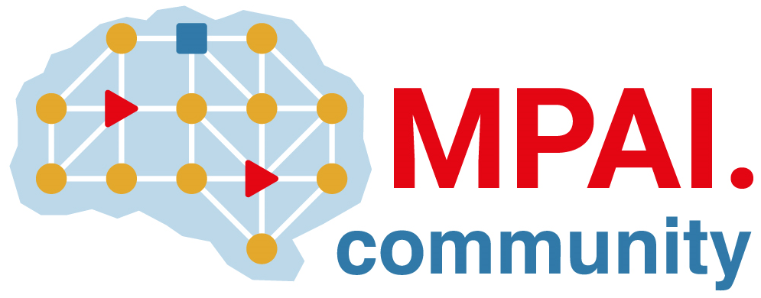 | Moving Picture, Audio and Data Coding by Artificial Intelligence  www.mpai.community

Public document
N1377 | 2023/09/29
Source | 36th MPAI General Assembly (MPAI-36)
Title | MPAI-36 Press Release
Target | MPAI Members

MPAI celebrates its third anniversary by publishing five standards

Geneva, Switzerland – 29 September 2023. MPAI, Moving Picture, Audio and Data Coding by Artificial Intelligence, the international, non-profit, and unaffiliated organisation developing AI-based data coding standards has concluded its 36th General Assembly (MPAI-36) approving the publication of five standards: AI Framework V2, Connected Autonomous Vehicle Architecture, Multimodal Conversation V2, MPAI Metaverse Model, and Portable Avatar Format, and one Conformance Testing of the Context-based Audio Enhancement standard.

In three years, MPAI has been able to produce nine standards in the areas of execution of AI applications, audio enhancement, autonomous vehicles, financial data, ecosystem governance, MPAI multimodal conversation, metaverse, neural network watermarking, and portable avatars, produced a second extended version for three, and is now looking forward to receiving responses to two Calls for Technologies on AI for Health and XR Venues – Live Theatrical Stage performance. More information about standards and projects can be found here.

Ominously, the date of the 36th General Assembly falls on the eve of the third anniversary of the MPAI foundation.

MPAI is continuing its work plan that involve the following activities:

- AI Framework (MPAI-AIF): reference software, conformance testing, and application areas.
- Avatar Representation and Animation (MPAI-PAF): reference software, conformance testing and new areas.
- Context-based Audio Enhancement (CAE-DC): new projects.
- Connected Autonomous Vehicle (MPAI-CAV): Functional Requirements of CAV architecture.
- Compression and Understanding of Industrial Data (MPAI-CUI): preparation for extension of existing standard.
- Multimodal Conversation (MPAI-MMC): reference software, drafting conformance testing, and new areas.
- MPAI Metaverse Model (MPAI-MMM): reference software and metaverse technologies requiring standards.
- Neural Network Watermarking (MPAI-NNW): reference software for enhanced applications.
- AI Health (MPAI-AIH): preparation for the development of the standard.
- End-to-End Video Coding (MPAI-EEV): video coding using AI-based End-to-End Video coding.
- AI-Enhanced Video Coding (MPAI-EVC). video coding with AI tools added to existing tools.
- Server-based Predictive Multiplayer Gaming (MPAI-SPG): technical report on mitigation of data loss and cheating.
- XR Venues (MPAI-XRV): preparation for the development of the standard.

Legal entities and representatives of academic departments supporting the MPAI mission and able to contribute to the development of standards for the efficient use of data can become MPAI members.

Please visit the MPAI website, contact the MPAI secretariat for specific information, subscribe to the MPAI Newsletter and follow MPAI on social media: LinkedIn, Twitter, Facebook, Instagram, and YouTube.

