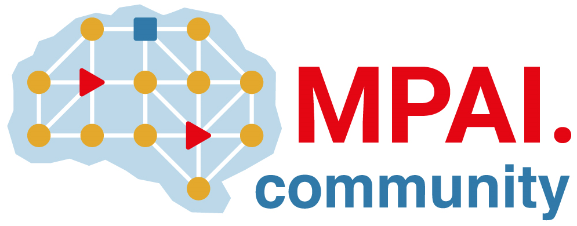 | Moving Picture, Audio and Data Coding by Artificial Intelligence  www.mpai.community

Public document
N1422 | 2023/10/25
Source | 37th MPAI General Assembly (MPAI-37)
Title | MPAI-37 Press Release
Target | MPAI Members

MPAI start new project on “AI for Health”

Geneva, Switzerland – 25 October 2023. MPAI, Moving Picture, Audio and Data Coding by Artificial Intelligence, the international, non-profit, and unaffiliated organisation developing AI-based data coding standards has concluded its 37th General Assembly (MPAI-37) approving the start of a new project on AI for Health.

AI for Health (MPAI-AIH) envisages a system where clients acquire and process individuals’ health data using shared AI models and upload data to the backend with attached licences expressed by smart contracts. Third parties may process health data based on the relevant licence. From time to time the backend uses federated learning to collect and use the AI models to retrain the common models. These are redistributed to all clients.

MPAI is continuing its work plan that involve the following activities:
- AI Framework (MPAI-AIF): reference software, conformance testing, and application areas.
- Avatar Representation and Animation (MPAI-PAF): reference software, conformance testing and new areas.
- Context-based Audio Enhancement (CAE-DC): new projects.
- Connected Autonomous Vehicle (MPAI-CAV): Functional Requirements of CAV architecture.
- Compression and Understanding of Industrial Data (MPAI-CUI): preparation for extension of existing standard.
- Multimodal Conversation (MPAI-MMC): reference software, drafting conformance testing, and new areas.
- MPAI Metaverse Model (MPAI-MMM): reference software and metaverse technologies requiring standards.
- Neural Network Watermarking (MPAI-NNW): reference software for enhanced applications.
- End-to-End Video Coding (MPAI-EEV): video coding using AI-based End-to-End Video coding.
- AI-Enhanced Video Coding (MPAI-EVC). video coding with AI tools added to existing tools.
- Server-based Predictive Multiplayer Gaming (MPAI-SPG): technical report on mitigation of data loss and cheating.
- XR Venues (MPAI-XRV): preparation for the development of the standard.

Legal entities and representatives of academic departments supporting the MPAI mission and able to contribute to the development of standards for the efficient use of data can become MPAI members.

Please visit the MPAI website, contact the MPAI secretariat for specific information, subscribe to the MPAI Newsletter and follow MPAI on social media: LinkedIn, Twitter, Facebook, Instagram, and YouTube.

