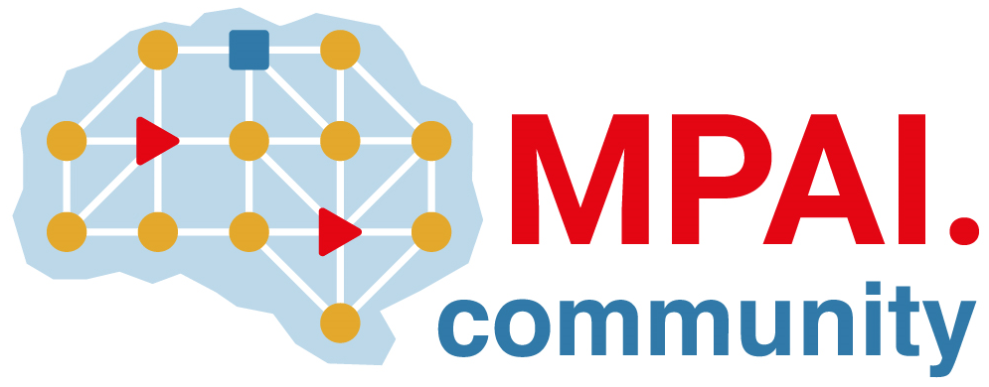 | Moving Picture, Audio and Data Coding by Artificial Intelligence  www.mpai.community

Public document
N1446 | 2023/10/25
Source | Requirements (EEV)
Title | Requirements (EEV) progress report and plans
Target | MPAI-37

Requirements (EEV) has made significant progress in learned video coding for drone videos in its previous study. The EEV group has made a practical step in preparing the draft to standardize a neural video codec.

In this round of meeting cycle, EEV group is constructing the EEV-0.5 model. The bi-directional inter predictive coding structure is planned. One of the main challenging issue of constructing such structure is how to design a proper training methodology and strategy for stable training procedure.
The existing methods reported in related publications might not be easily reproduced. As such, a scalable and robust training process should be defined by the group.

