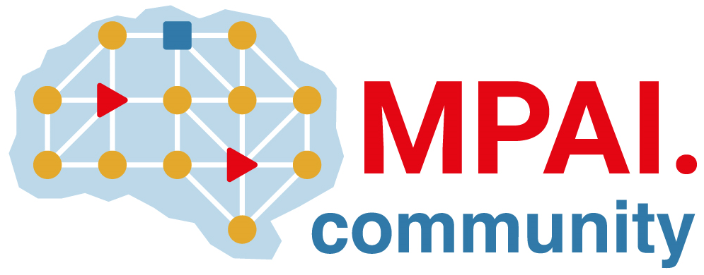 | Moving Picture, Audio and Data Coding by Artificial Intelligence  www.mpai.community

Public document
N1461 | 2023/11/22
Source | 38th MPAI General Assembly (MPAI-38)
Title | MPAI-38 Press Release
Target | MPAI Members

MPAI releases new version of Neural Network Watermarking Reference Software; starts new project on XR Venues – Live Theatrical Stage Performance

Geneva, Switzerland – 22 November 2023. MPAI, Moving Picture, Audio and Data Coding by Artificial Intelligence, the international, non-profit, and unaffiliated organisation developing AI-based data coding standards has concluded its 38th General Assembly (MPAI-38) approving the release of a new version of its Neural Network Watermarking reference software and the start of the development of the new XR Venues – Live Theatrical Stage Performance standard.

The new version of the Neural Network Watermarking (MPAI-NNW) reference software makes it possible to upgrade conventional AI-based processing workflows with traceability and integrity checking functions. For instance, it is now possible to add AI Modules to an MPAI-AIF workflow to detect whether a particular text was indeed produced by the expected service or AI Module (AIM). Register to attend the online presentation on 2023/12/12T15:00 UTC.

The XR Venues (MPAI-XRV) – Live Theatrical Stage Performance standard project specifies functions and interfaces of AI Modules designed to automate live multisensory immersive stage performances which ordinarily require extensive on-site show control staff to operate. By running AI Workflows (AIW) composed of AIMs, it will be possible to obtain a more direct, precise yet spontaneous show implementation and control of multiple complex systems to achieve the show director’s vision.

MPAI is continuing its work plan that involve the following activities:
- AI Framework (MPAI-AIF): reference software, conformance testing, and application areas.
- AI for Health (MPAI-AIH) development of the standard.
- Context-based Audio Enhancement (CAE-DC): new projects are bewing.
- Connected Autonomous Vehicle (MPAI-CAV): Functional Requirements of data used by the CAV architecture.
- Compression and Understanding of Industrial Data (MPAI-CUI): preparation for an extension to existing standard.
- Multimodal Conversation (MPAI-MMC): reference software, drafting conformance testing, and new areas.
- MPAI Metaverse Model (MPAI-MMM): reference software and metaverse technologies requiring standards.
- Neural Network Watermarking (MPAI-NNW): reference software for enhanced applications.
- Portable Avatar Format (MPAI-PAF): reference software, conformance testing and new areas.
- End-to-End Video Coding (MPAI-EEV): video coding using AI-based End-to-End Video coding.
- AI-Enhanced Video Coding (MPAI-EVC). video coding with AI tools added to existing tools.
- Server-based Predictive Multiplayer Gaming (MPAI-SPG): technical report on mitigation of data loss and cheating.
- XR Venues (MPAI-XRV): development of the standard.

Legal entities and representatives of academic departments supporting the MPAI mission and able to contribute to the development of standards for the efficient use of data can become MPAI members.

Please visit the MPAI website, contact the MPAI secretariat for specific information, subscribe to the MPAI Newsletter and follow MPAI on social media: LinkedIn, Twitter, Facebook, Instagram, and YouTube.

