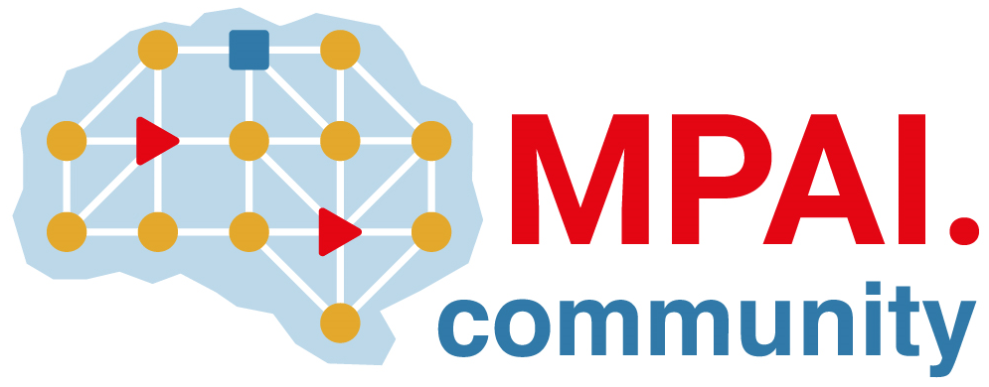 | Moving Picture, Audio and Data Coding by Artificial Intelligence  www.mpai.community

N1495 | 2023/11/22
Source | Requirements (EEV)
Title | Requirements (EEV) progress report and plans
Target | MPAI-38

Requirements (EEV) has made significant progress in learned video coding for drone videos in its previous study. The EEV group has made a practical step in preparing the draft to standardize a neural video codec.

In this round of meeting cycle, EEV group is constructing the EEV-0.5 model. The bi-directional inter predictive coding structure has been implemented. Our current progress includes a hierarchical coding structure together with a temporal quality adjustment module. More experiments and analysis are under construction.

