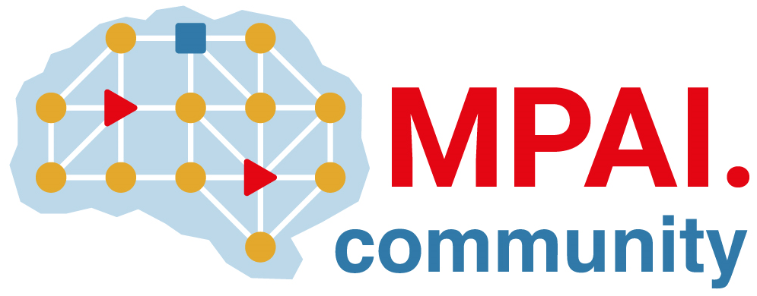 | Moving Picture, Audio and Data Coding  by Artificial Intelligence  www.mpai.community

Public document
N1500 | 2023/11/22
Source | Requirements (SPG)
Title | MPAI-SPG Status report
Target | MPAI Members

Progresses

Due to lack of internal resources, this past month has been relatively slow in terms of progress on the project. As we temporarily lost one of our key resources for the development side nothing to report on that side. On the other hand, there have been some minor updates to the technical report.
No
Towards the end of the month we welcomed into the working team a new thesis student from Politecnico di Torino who will be occupied full time on the project progress. So far, he has worked mostly in getting to know the project, its development history and the used tools.

Future Plans

- Make progress in the Technical Report document.
- Define the objectives for the new thesis student
- Organize the new student work and establish key goals oriented to the improvement of the current implemented solution.

