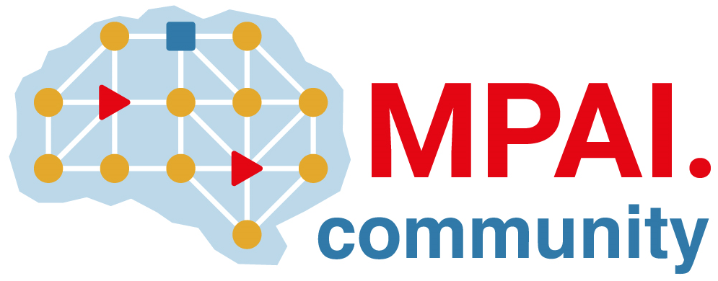 | Moving Picture, Audio and Data Coding by Artificial Intelligence  www.mpai.community

Public document
N1508 | 2023/12/20
Source | 39th MPAI General Assembly (MPAI-39)
Title | MPAI-39 Press Release
Target | MPAI Members

MPAI publishes Context-based Audio Enhancement and Object and Scene Description for Community Comments

Geneva, Switzerland – 20 December 2023. MPAI, Moving Picture, Audio and Data Coding by Artificial Intelligence, the international, non-profit, and unaffiliated organisation developing AI-based data coding standards has concluded its 39th General Assembly (MPAI-39) approving the publication of the Context-based Audio Enhancement standard and Object and Scene Description standard for Community Comments.

The draft of the Context-based Audio Enhancement (MPAI-CAE) Version 2.1 standard enhances the compatibility of the Audio with the Visual and the Audio-Visual Scene Description specified by the draft Object and Scene Description (MPAI-OSD) standard. Both are published with requests for Community Comments. These are due by 2024/01/23T23:59 UTC and 17T23:58 UTC, respectively, to secretariat@mpai.community.

MPAI is continuing its work plan that involving the following activities:
- AI Framework (MPAI-AIF): reference software, conformance testing, and application areas.
- AI for Health (MPAI-AIH): reference model and technologies for a system enabling clients to improve models processing health data and federated learning to share the training.
- Context-based Audio Enhancement (CAE-DC): new projects are brewing.
- Connected Autonomous Vehicle (MPAI-CAV): Functional Requirements of the data used by the MPIA-CAV – Architecture standard.
- Compression and Understanding of Industrial Data (MPAI-CUI): preparation for an extension to existing standard that includes support for more corporate risks.
- Human and Machine Communication (MPAI-HMC): model and technologies enabling a human or a machine to communicate with a machine or a human in a different cultural environment.
- Multimodal Conversation (MPAI-MMC): drafting reference software and conformance testing, and exploring new areas.
- MPAI Metaverse Model (MPAI-MMM): reference software and metaverse technologies requiring standards.
- Neural Network Watermarking (MPAI-NNW): reference software for enhanced applications.
- Portable Avatar Format (MPAI-PAF): reference software, conformance testing and new areas.
- End-to-End Video Coding (MPAI-EEV): video coding using AI-based End-to-End Video coding.
- AI-Enhanced Video Coding (MPAI-EVC). video coding with AI tools added to existing tools.
- Server-based Predictive Multiplayer Gaming (MPAI-SPG): technical report on mitigation of data loss and cheating.
- XR Venues (MPAI-XRV): development of the standard.

Legal entities and representatives of academic departments supporting the MPAI mission and able to contribute to the development of standards for the efficient use of data can become MPAI members.

Please visit the MPAI website, contact the MPAI secretariat for specific information, subscribe to the MPAI Newsletter and follow MPAI on social media: LinkedIn, Twitter, Facebook, Instagram, and YouTube.

