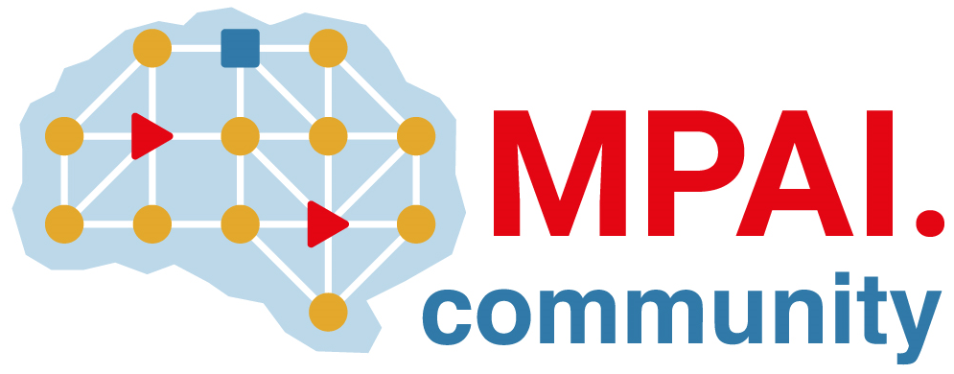 | Moving Picture, Audio and Data Coding by Artificial Intelligence  www.mpai.community

Public document
N1541 | 2023/12/20
Source | Requirements (EEV)
Title | Requirements (EEV) progress report and plans
Target | MPAI-39

Requirements (EEV) has made significant progress in learned video coding and there are four major versions of reference software. The EEV group has made a practical step in preparing the draft to standardize a neural video codec.

In this round of GA meeting cycle, EEV group is still constructing the EEV-0.5 model. With the help of research group from Tsinghua Univ., the optimal bit allocation algorithm and model has been investigated on the top of EEV-0.4 model. And it is observed that over 10% of coding gain could be obtained. Moreover, the ongoing work of bi-directional prediction coding also offers significant coding efficiency improvement on the top of previous EEV model.

The EEV group is expected to release its next version of reference software in Next March. And it is expected that over 20% of rate-distortion performance improvement can be obtained.

