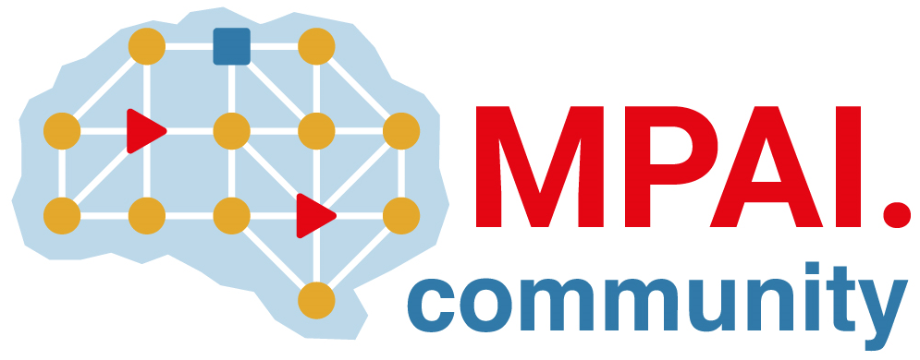 | Moving Picture, Audio and Data Coding  by Artificial Intelligence  www.mpai.community

Public document
N1544 | 2023/12/20
Source | Requirements (SPG)
Title | MPAI-SPG Status report
Target | MPAI Members

Progresses

Our newly recruited resource, a thesis student, is now exploring the possibilities offered by autonomous agents as a viable solution to replicate players’ behaviour in the case of network issues (data loss and latency). He is in a preliminary state of research familiarizing with the working environment of machine learning agents offered by the main game engine we use for development, Unity.

In parallel, we have made advancements to the technical report.

Future Plans

- Make progress in the Technical Report document.
- Define the objectives for the new thesis student
- Organize the new student work and establish key goals oriented to the improvement of the current implemented solution.

