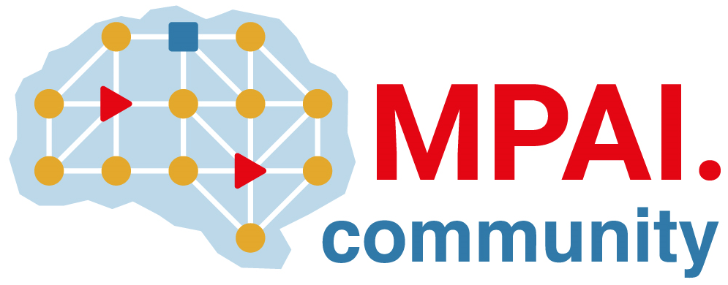 | Moving Picture, Audio and Data Coding by Artificial Intelligence  www.mpai.community

Public document

N1589 | 2024/1/24
Source | Requirements (EEV)
Title | Requirements (EEV) progress report and plans
Target | MPAI-40

Requirements (EEV) has made significant progress in learned video coding and there are four major versions of reference software. The EEV group has made a practical step in preparing the draft to standardize a neural video codec.

In this round of GA meeting cycle, EEV group is still constructing the EEV-0.5 model. A preliminary version of EEV-0.5 model has been developed, supporting bi-directional inter prediction. Another technical strength is that the newest model supports dual motion vector based prediction plus feature space predictor fusion. Such design enhances inter prediction efficacy and the corresponding residual coding module is also simplified.

The current EEV-0.5 model outperforms EEV-0.4 model by around 50% bitrate reduction using YUV-PSNR metric (weighted by 6:1:1). More justifications and evaluations are under construction and investigation.

The EEV group has also set up a timeline for its subsequent model development. The high-level syntax (HLS), model quantization and other methods will be introduced in next steps.

