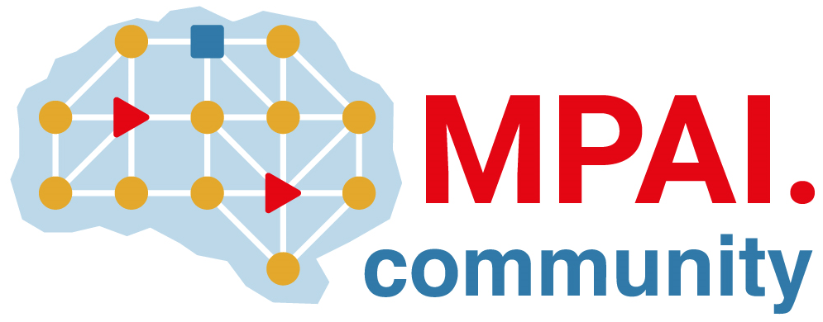 | Moving Picture, Audio and Data Coding by Artificial Intelligence  www.mpai.community

Public document
N1635 | 2024/2/21
Source | Requirements (EEV)
Title | Requirements (EEV) progress report and plans
Target | MPAI-41

Requirements (EEV) has made significant progress in learned video coding and there are four major versions of reference software. The EEV group has made a practical step in preparing the draft to standardize a neural video codec.

In this round of GA meeting cycle, EEV group is continuously constructing the EEV-0.5 model. The extensive evaluation processof EEV-0.5 model is happening. The EEV-0.5 model design enhances inter prediction efficacy and the corresponding residual coding module is also simplified.

The current EEV-0.5 model outperforms EEV-0.4 model by around 50% bitrate reduction using YUV-PSNR metric. More justifications and evaluations are under construction and investigation.

