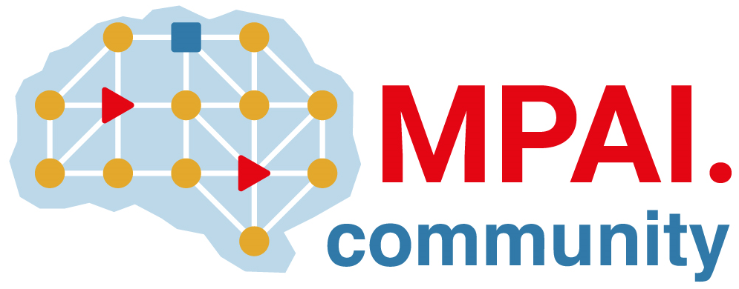 | Moving Picture, Audio and Data Coding by Artificial Intelligence  www.mpai.community

Public document
N1699 | 2024/04/17
Source | 43rd MPAI General Assembly (MPAI-43)
Title | MPAI-43 Press Release
Target | MPAI Members

MPAI publishes the draft AI Module Profile Standard with a request for Community Comments

Geneva, Switzerland – 17 April 2024. MPAI – Moving Picture, Audio and Data Coding by Artificial Intelligence – the international, non-profit, and unaffiliated organisation developing AI-based data coding standards has concluded its 43rd General Assembly (MPAI-43) approving the publication of the draft AI Module Profile V1.0 Standard with a request for Community Comments.

AI Module Profiles (MPAI-PRF) V1.0 enables the signalling of AI Module Attributes – input data, output data, or functionality – that uniquely characterise an AIM instance. An AIM Profile is thus a label that uniquely identifies the set of AIM Attributes that are either supported or not supported by that AIM instance. Anybody can submit comments to the draft by sending an email to the MPAI secretariat by 2024/05/08T23:59.

MPAI also informs that the code, the presentation file, and the video recording of the V1.1 version of the Neural Network Watermarking (MPAI-NNW) Reference Software Specification presented of the on the 16th of April are now publicly available. The software enables a user to make queries that include a text and an image and obtain a watermarked vocal response that enables the issuer of the query to ascertain that the response is from the intended source. The second software can be used to run watermarked AI-based applications on resource-constrained processing platforms without significant performance loss.

MPAI is continuing its work plan that involving the following activities:
- AI Framework (MPAI-AIF): developing open-source applications based on the AI Framework.
- AI for Health (MPAI-AIH): developing the specification of a system enabling clients to improve models processing health data and federated learning to share the training.
- Context-based Audio Enhancement (CAE-DC): preparing new projects.
- Connected Autonomous Vehicle (MPAI-CAV): Functional Requirements of the data used by the MPIA-CAV – Architecture standard.
- Compression and Understanding of Industrial Data (MPAI-CUI): preparation for an extension to existing standard that includes support for more corporate risks.
- End-to-End Video Coding (MPAI-EEV): video coding using AI-based End-to-End Video coding.
- AI-Enhanced Video Coding (MPAI-EVC). video coding with AI tools added to existing tools.
- Human and Machine Communication (MPAI-HMC): developing reference software.
- Multimodal Conversation (MPAI-MMC): developing reference software and conformance testing and exploring new areas.
- MPAI Metaverse Model (MPAI-MMM): developing reference software specification and identifying metaverse technologies requiring standards.
- Neural Network Watermarking (MPAI-NNW): reference software for enhanced applications.
- Portable Avatar Format (MPAI-PAF): reference software, conformance testing and new areas.
- Server-based Predictive Multiplayer Gaming (MPAI-SPG): technical report on mitigation of data loss and cheating.
- XR Venues (MPAI-XRV): development of the standard.

Legal entities and representatives of academic departments supporting the MPAI mission and able to contribute to the development of standards for the efficient use of data can become MPAI members.

Please visit the MPAI website, contact the MPAI secretariat for specific information, subscribe to the MPAI Newsletter and follow MPAI on social media: LinkedIn, Twitter, Facebook, Instagram, and YouTube.

