Moving Picture, Audio and Data Coding
by Artificial Intelligence
www.mpai.community

Public document
N1731 | 2024/04/17
Source | MMC-DC
Title | Technical Specification: AI Module Profiles (MPAI-PRF) WD0.3 for Community Comments
Target | MPAI Members

Moving Picture, Audio and Data Coding
by Artificial Intelligence www.mpai.community

MPAI Technical Specification

AI Module Profiles
MPAI-PRF

WD0.3 for Community Comments

WARNING

Use of the technologies described in this Technical Specification may infringe patents, copyrights or intellectual property rights of MPAI Members or non-members.

MPAI and its Members accept no responsibility whatsoever for damages or liability, direct or consequential, which may result from the use of this Technical Specification.

Readers are invited to review Annex 1 - Notices and Disclaimers.

© Copyright MPAI 2021-2024. All rights reserved.
MPAI Technical Specification
AI Module Profiles (MPAI-PRF) V1.0
(under development)

Contents
Foreword (Informative) 4
1 Introduction (Informative) 5
2 Scope 5
3 Terms and Definitions 5
4 References 6
4.1 Normative References 6
4.2 Informative References 6
5 AIMs requiring profiles 6
6 Profile signalling 7
6.1 Syntax 8
6.2 Semantics 8
7 AI Module Profiles 9
7.1 Entity Context Understanding (HMC-ECU) 9
7.1.1 Definition 9
7.1.2 Specification 9
7.1.3 Attributes 9
7.2 Entity Dialogue Processing (MMC-EDP) 10
7.2.1 Definition 10
7.2.2 Specification 10
7.2.3 Attributes 10
7.3 Natural Language Understanding (MMC-NLU) 11
7.3.1 Definition 11
7.3.2 Specification 11
7.3.3 Attributes 11
7.4 Personal Status Extraction (MMC-PSE) 11
7.4.1 Definition 11
7.4.2 Specification 11
7.4.3 Attributes 12
7.5 Text and Speech Translation 12
7.5.1 Definition 12
7.5.2 Specification 12
7.5.3 Attributes 13
7.6 Audio-Visual Scene Rendering (PAF-AVR) 13
7.6.1 Definition 13
7.6.2 Specification 13
7.6.3 Attributes 13
7.7 Personal Status Display (PAF-PSD) 13
7.7.1 Definition 13
7.7.2 Specification 14
7.7.3 Attributes 14
7.8 Text-to-Speech (MMC-TTS) 14
7.8.1 Definition 14
7.8.2 Specification 14
7.8.3 Attributes 14
Annex 1 - Notices and Disclaimers Concerning MPAI Standards (Informative) 16
Annex 2 - General MPAI Terminology 18
Annex 3 - Patent Declarations 22

Foreword (Informative)
In recent years, Artificial Intelligence (AI) and related technologies have been applied to a broad range of applications, have started affecting the life of millions of people and are expected to do so even more in the future. As digital media standards have positively influenced industry and billions of people, so AI-based data coding standards are expected to have a similar positive impact. Moving Picture, Audio, and Data Coding by Artificial Intelligence (MPAI) has been established to develop standards that promote the efficient use of data especially using Artificial Intelligence technologies.

To establish a framework for the pursuit of its mission. MPAI has developed Technical Specification: Governance of the MPAI Ecosystem [1]. This defines the following elements: Standards, i.e., the ensemble of Technical Specifications, Reference Software, Conformance Testing, and Performance Assessment; Implementers of MPAI Technical Specifications; the MPAI Store in charge of making AIMs and AIWs submitted by Implementers available to Integrators and End-Users; Performance Assessors, independent entities assessing the performance of implementations in terms of Reliability, Replicability, Robustness, and Fairness; and End Users.

To facilitate the development of smaller-scale high-performance components and the availability of solution with improved explainability, MPAI has developed another foundational Technical Specification: Artificial Intelligence Framework (MPAI-AIF) [2]. This specifies an environment enabling initialisation, dynamic configuration, and control of AIWs in the standard AI Framework environment depicted in Figure 1.

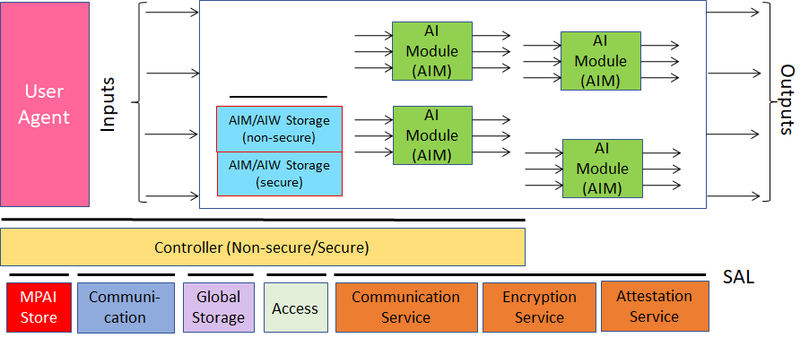
Figure 1 - The AI Framework (MPAI-AIF) V2 Reference Model
An AI Framework can execute AI applications called AI Workflows (AIW). An AI Workflow can include interconnected AI Modules (AIM). AI Modules can be Composite if they include interconnected AIMs or Basic if they are not Composite.

Introduction (Informative)
Some AIMs receive more/less input and produce more/less output data than an AIM with the same name that is used in other AIWs even though they nominally perform the same functions. For instance, the Natural Language Understanding (MMC-NLU) AIM in the Conversation with Emotion Use Case (MMC-CWE) receives Recognised Text as input and produces Refined Text and Meaning. However, the MMC-NLU AIM used in the Communicating Entities in Context Communication Use Case (HMC-CEC) may also use Scene Geometry and Audio and/or Visual Object Instance IDs to achieve a better understanding of the textual sentence.

Since it is not realistic to require that all MMC-NLU AIMs be equipped with the additional logic required to exploit Spatial and Object information to provide Refined Text and Meaning, Technical Specification: AI Module Profiles (MPAI-PRF) provides a mechanism that unambiguously signals which characteristics of an AIM – called Attributes in the following – are supported by the AIM.

Table 1 defined the Terms specific of this Technical Specification and Table 5 those used across MPAI Technical Specifications. Chapters, Sections, and Annexes are Normative unless they are explicitly identified as Informative.

Scope
Technical Specification: AI Module Profiles (MPAI-PRF) enables the signalling of AI Module Attributes – input data, output data or functionality – that uniquely characterise an AIM instance. An AIM Profile is thus a label that uniquely identifies the set of AIM Attributes that are either supported or not supported by that AIM instance.

MPAI-PRF has been developed by the Context-based Audio Enhancement (MPAI-CAE), Multimodal Conversation (MPAI-MMC), and Portable Avatar Format (MPAI-PAF) Development Committees. MPAI may issue new Versions of this Technical Specification or new Technical Specifications.

Terms and Definitions
A dash “-” preceding a Term in Table 1 indicates the following readings according to the font:
- Normal font: the Term in the table without a dash and preceding the one with a dash should be read before that Term. For example, “Data” and “- Type” means "Avatar Model.”
- Italic font: the Term in the table without a dash and preceding the one with a dash should be read after that Term. For example, “AI Module” and “- Basic” means "Basic AI Module.”

Table 1 - Terms used in this Technical Specification
Term | Definition
AI Module (AIM) | A data processing component performing a Function by processing AIM-specific Input Data and producing AIM-specific Output Data.
- Profile | The label that uniquely identifies a set of Attributes.
- Attribute | An input Data or an output Data or a functionality, such as the ability to translate.
- Basic | An AIM that does not aggregate other AIMs.
- Composite | An AIM aggregating more than one AIM.
Avatar | An Object rendered to represent a Human of a Machine in a virtual space.
- Model | An inanimate Avatar exposing animation interfaces.
- Portable | A Data Type including Avatar ID, Time, Visual Environment, Spatial Attitude, Avatar Model, Body Descriptors, Face Descriptors, Language Preference, Speech Coding, Speech Data, Text, and Personal Status.
Body | A digital representation of a human body.
- Object | A Data Type representing the body of an Entity, head included, face excluded.
- Descriptors | A Data Type representing the features of an Entity’s Body.
Context | Information surrounding an Entity and providing additional insight into the information the Entity communicates.
Data | Information in digital form.
- Format | A standard representation of Data.
- Type | An instance of Data with a specific Data Format
Entity | A human in a real environment or digitally represented as a Digitised Human in a Virtual Environment a Digital or a Virtual Human in a Virtual Environment.
Face | A digital representation of a human face.
- Descriptors | A Data Type representing the motion and conveying information on the Personal Status of the face of a human or an avatar.
- Objects | A Data Type representing the face of an Entity.
Factor | One of Cognitive State, Emotion, and Social Attitude
Modality | One of Text, Speech, Face, or Gesture.
Object | Data that can be rendered to cause an Experience.
- Audio | A Data Type representing an object or a computer-generated Object that can be rendered to and perceived by a human ear.
- Audio-Visual | An Object composed of Audio and Visual Objects sharing the same Spatial Attitude.
- Instance | The instance of an Audio Object.
- Visual | The digital representation of an object captured by an electromagnetic or high-frequency audio signal or computer-generated that can be rendered to and perceived by a human eye.
Personal Status | A Data Type representing the ensemble of information internal to a person expressed by 3 Factors (Cognitive State, Emotion, Social Attitude) conveyed by one or more Modalities (Text, Speech, Face, and Gesture).
Point of View | The Spatial Attitude of an Entity user looking at an Environment.
Scene Descriptors | The digital representation of the features of a scene.
Audio | A Data Type representing the Audio Objects and their spatial arrangement in an Audio Scene.
Audio-Visual | A Data Type representing the Audio-Visual Objects and their spatial arrangement in an Audio-Visual Scene.
Visual | A Data Type representing the Visual Objects and their spatial arrangement in a Visual Scene.
Scene Geometry | The digital representation of the Object arrangement of a Scene.
- Audio | A Data Type representing the spatial arrangement of the Audio Objects of a Scene.
- Audio-Visual | A Data Type representing the spatial arrangement of the Audio, Visual, and Audio-Visual Objects of a Scene.
- Visual | A Data Type representing the spatial arrangement of the Visual Objects of a Scene.
Speech | Digital representation of analogue speech sampled at a frequency between 8 kHz and 96 kHz with a number of bits/sample of 8, 16 or 24, and non-linear and linear quantisation or compressed. Data with characteristics of Speech may be synthetically produced.
- Descriptors | A Data Type representing information elements incorporated in a Speech Segment, e.g., personal identity, Personal Status, additional factors such as vocal tension, creakiness, whispery quality, etc.
- Model | A Neural Network trained to generate utterances with specific Speech Descriptors.
- Object | An Object described by Speech Descriptors.
Text | A series of characters drawn from a finite alphabet of a Character Set.
- Descriptors | A Data Type including the digital representation of the features of Text.
- Object | A string of Text.
- Recognised | The Text produced by the Automatic Speech Recognition AIM.

References

Normative References
- MPAI; Technical Specification; MPAI Ecosystem Governance (MPAI-GME) V1.1; https://mpai.community/standards/mpai-gme/.
- MPAI; Technical Specification: AI Framework (MPAI-AIF) V2.0; https://mpai.community/standards/mpai-aif/.
- MPAI; Technical Specification: Human and Machine Communication (MPAI-HMC) V1.0; https://mpai.community/standards/mpai-hmc/.
  - Entity and Context Understanding: https://mpai.community/standards/aiws-and-aims/entity-context-understanding-hmc-ecu/.
- MPAI; Technical Specification: Multimodal Conversation (MPAI-MMC) V2.1; https://mpai.community/standards/mpai-mmc/.
  - Entity Dialogue Processing: https://mpai.community/standards/aiws-and-aims/entity-dialogue-processing-hmc-edp/.
  - Natural Language Understanding: https://mpai.community/standards/aiws-and-aims/natural-language-understanding-hmc-nlu/.
  - Personal Stats Extraction: https://mpai.community/standards/aiws-and-aims/personal-status-extraction-mmc-pse/.
  - Text and Speech Translation: https://mpai.community/standards/aiws-and-aims/text-and-speech-translation-mmc-tst/.
  - Text To Speech: MMC-TTS is specified at https://mpai.community/standards/aiws-and-aims/text-to-speech-mmc-tts/.
- MPAI; Technical Specification: Portable Avatar Format (MPAI-PAF) V1.1; https://mpai.community/standards/mpai-paf/.
  - Audio-Visual Rendering: https://mpai.community/standards/aiws-and-aims/audio-visual-scene-rendering-hmc-avr/.
  - Personal Status Display: PAF-PSD is specified at https://mpai.community/standards/aiws-and-aims/personal-status-display-paf-psd/.
- ISO 639:2023 - Code for individual languages and language groups; https://www.iso.org/standard/74575.html

Informative References
- MPAI; The MPAI Statutes; https://mpai.community/statutes/.
- MPAI; The MPAI Patent Policy; https://mpai.community/about/the-mpai-patent-policy/.

AIMs requiring profiles
The first column of Table 2 provides the current list of names of AIMs requiring Profiles, the second column their acronyms, and the third column the JSON Metadata [2].

Table 2 - AIMs requiring Profiles
Name | AIMs | JSON
Audio-Visual Scene Rendering | PAF-AVR | X
Entity Context Understanding | HMC-ECU | X
Entity Dialogue Processing | MMC-EDP | X
Natural Language Understanding | MMC-NLU | X
Personal Status Display | PAF-PSD | X
Personal Status Extraction | MMC-PSE | X
Text and Speech Translation | MMC-TST | X
Text-to-Speech | MMC-TTS | X

This list may be subject to future revision because:
- Some AIMs currently having a single form, may subsequently found to require Profiles.
- The functionality of existing AIMs may be extended in a way that requires Profiles.
- New AIMs may be specified that require Profiles.

Note that this document does not distinguish between Composite and Basic AIMs.

Profile signalling
The 23 Attributes of Table 3 represented with 3-character codes have been found necessary to identify Attributes of the AI Module of Table 2.

Table 3 - Coding of AIM Attributes
Attributes | Code
Audio Object | AUO
Audio-Visual Scene Geometry | AVG
Avatar Model | AVM
Body Object | BDO
Body Descriptors | BDD
Face ID | FCI
Face Object | FCO
Face Descriptors | FCD
Input Personal Status | IPS
Language Preferences | LGP
Memory | MEM
Speech Model | SPM
Object Instance ID | OII
Point of View | POV
Portable Avatar | PAV
Speech Descriptors | SPD
Speaker ID | SPI
Speech Object | SPO
Text Descriptors | TXD
Text Object | TXO
Recognised Text | TXR
Translation | TRN
Visual Object | VIO

Thus, a specific AIM Profile will require:
- The three characters identifying the Technical Specification that specifies the AIM.
- The three characters identifying the AIM of that Technical Specification.
- The Version and Subversion of the Technical Specification.
- The Profile-specific sequence of coded Attributes drawn from Table 3.

For instance, the Profile of a Natural Language Understanding (HMC-NLU) AIM that does not handle spatial information (see Section 7.3) is labelled in two ways, allows more compact signalling matched to the number of Attributes supported by an AIM:

Removing unsupported Attributes | MMC-NLU-V2.1(ALL-AVG-OII)
Adding supported Attributes | MMC-NLU-V2.1(NUL+TXO+TXR)

Attributes, however, are not always sufficient to identify the capabilities of an AIM instance. For instance, an AIM instance of Personal Status Display (PAF-PSD) may support Personal Status, but only the Speech (PS-Speech) and Face (PS-Face) Personal Status Factors. This is illustrated by the following two examples:

Removing unsupported Attributes | PAF-PSD-V1.1(ALL@IPS#SPE#FCE)
Adding supported Attributes | PAF-PSD-V1.1(NUL+TXT+AVM@IPS#FCE#GST

Here @ prefixed to IPS signals that the AIM supports Personal Status, but only of Speech and Face and of Face and Gesture represented by PSS, PSF, and GST, the codes of the PS-Speech, PS-Face, and PS-Gesture Sub-Attributes, respectively (the full list of Personal Status Sub-Attributes is provided by Table 4). The second case may apply for a sign-language capable AIM.

Currently, MPAI-PRF supports another use of Sub-Attributes. The Test and Speech Translation AIM needs Sub-Attributes to signal which languages are supported in which direction as exemplified below:

Removing unsupported Attributes | MMC-TST-V2.1(NUL@TRN#eng→ita)
Adding supported Attributes | MMC-TST-V2.1(ALL-ISD@TRN#kor↔fra#ger→swa)

The first case refers to an AIM than only supports text translation from English to Italian and the second to an AIM that does not support Speech Descriptors but supports text and speech translation from both Korean to and from French, and from German to Swahili (the TRN Sun-Attributes are specified in Table 4).

The capabilities of an AIM can thus be represented along two dimensions: the first relates to its Attributes and is called Profile and the second relates to its Sub-Attributes and is called Level. Table 4 lists the Sub-Attributes of the Personal Status and Translation Attributes:

Table 4 - Attributes and Sub-Attributes
Attribute | Coded Attributes | Sub-Attributes | Coded Sub-Attributes
Personal Status | IPS | Text | TXT
 |  | Speech | SPE
 |  | Face | FCE
 |  | Gesture | GST
Translation | TRN | Language | 3-letter codes of [6], Part 3

An AIM implementing Attribute signalling does not expose the relevant Attribute interfaces.

JSON Syntax and Semantics
The following syntax and semantics can be used to define a file that may contain many Attributes and Sub-Attributes.

Syntax
{
"$schema": "http://json-schema.org/draft/2019-09/schema",
"title": "AIMProfiles",
"type": "object",
"properties": {
"Header": {
"type": "string",
"pattern": "^PRF-[0-9]{1,2}[.][0-9]{1,2}$"
},
"Profile": {
"type": "string",
"pattern": "^(ALL|NUL)([+-](AUO|AVG|AVM|BDO|BDD|FCI|FCO|FCD|IPS|LGP|MEM|SPM|OII|POV|PAV|SPD|SPI|SPO|TXD|TXO|TXR|TRN|VIO)|@IPS(#(TXT|SPE|FCE|GST))+|@TRN(#([a-z]{3})(<->|->)([a-z]{3}))+)+$"
}
}
}

{
"Header": "PRF-1.0",
"Profile": "NUL+TXO@IPS#SPE#FCE"
}

Semantics
Label | Size | Description
HEADER | 9 Bytes
- Standard | 3 Bytes | The three characters “PRF”
- Dash-separator | 1 Byte | The character “-”
- Version | 1 Byte | Major version
- Dot-separator | 1 Byte | The character “.”
- Subversion | 1 Byte | Minor version
Profile[] | N*4 Bytes | N is the number of Attributes
- Dash-separator | 1 Byte | The character “-”
- MissingAttribute[] | 3 Bytes | An Attribute of Table 3
- Plus separator | 1 Byte | The character “+”
  - AttributeCode
- “AddedAttribute[] | 3 Bytes | An Attribute of Table 3
- Hash-separator | 1 Bytes | The character “#”
- AttributeCode | 3 Byte | Sub-Attributes of Table 3

AI Module Profiles

Entity Context Understanding (HMC-ECU)

Definition
HMC-ECU
- Receives Audio-Visual Scene Descriptors.
- Processes the Descriptors to enable Machine to achieve understanding of the information conveyed by an Entity and its Context.
- Produces
  - Personal Status
  - Refined and Translated Text
  - Meaning
  - An Audio Instance ID
  - A Visual Instance ID
  - The Geometry of the Scene that contains the Audio and Visual Objects.
- Enables the downstream Entity Dialogue Processing AIM to produce a pertinent Communication Item as a Portable Avatar.

Specification
Entity and Context Understanding is specified at [3.1].

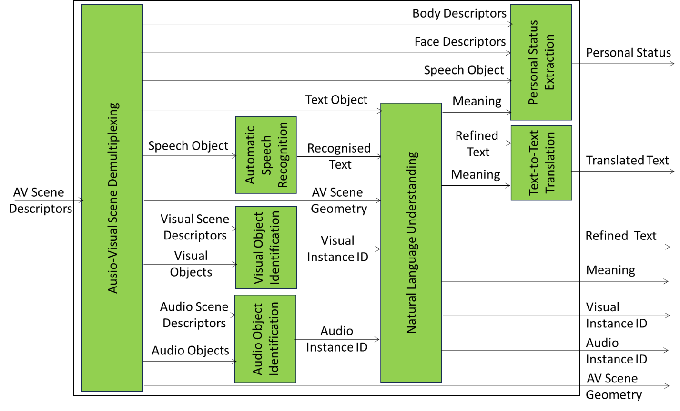
Figure 2 - Entity and Context Understanding

Attributes
An ECU AIM Profile is determined by whether the AIM uses one or more of the following attributes:

Attribute | Code | Function
Body Descriptors | BDD | HMC-ECU Receives Body Descriptors
Face Descriptors | FCD | HMC-ECU Receives Face Descriptors
Speech Object | SPO | HMC-ECU Receives Speech Object
Text Object | TXO | HMC-ECU Receives Text Object
Visual Object | VIO | HMC-ECU Receives Visual Object
Audio Object | AUO | HMC-ECU Receives Audio Object
Audio-Visual Scene Descriptors | AVS | HMC-ECU Receives Audio-Visual Scene Descriptors
Audio-Visual Scene Geometry | AVG | HMC-ECU Receives Audio-Visual Scene Geometry
Translation | TRN | HMC-ECU Translates Text Object

Entity Dialogue Processing (MMC-EDP)

Definition
MMC-EDP
- Receives:
  - Text Object
  - Object Instance ID
  - Input Personal Status
  - Text Descriptors
  - AV Scene Geometry
  - Speaker ID
  - Face ID
  - Memory
- Processes the information received
  - Handling one Speech Object at a time.
  - Taking past Speech Objects into account.
- Produces elements of the Machine Response to the data issued by the Entity in its Context in the form of:
  - Text.
  - Personal Status

Specification
MMC-EDP is specified at [4.1].

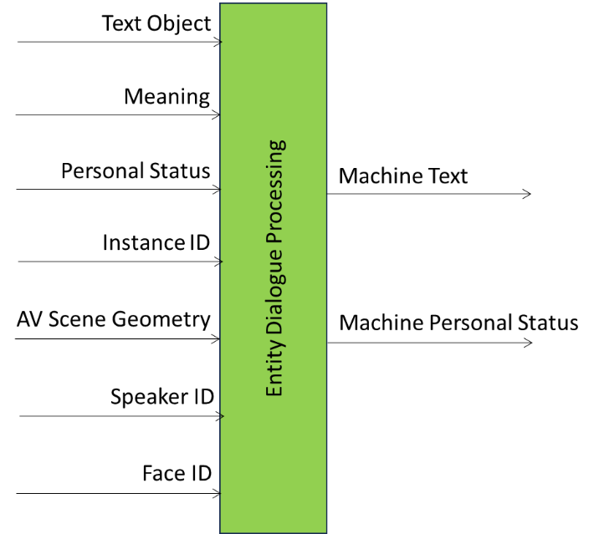
Figure 3 - Entity Dialogue Processing

Attributes
A Profile is determined by whether the AIM uses one or more of the following attributes:

Attribute | Code | Function
Text Object | TXO | MMC-EDP receives Text (directly from human or through NLU).
Object Instance ID | OII | MMC-EDP receives the ID of an A/V/AV Instance referenced in the dialogue.
Input Personal Status | IPS | MMC-EDP receives Personal Status.
Text Descriptors | TXD | MMC-EDP receives Meaning.
AV Scene Geometry | AVG | MMC-EDP receives AV Scene Geometry to enable it to locate the Object.
Speaker ID | SPI | MMC-EDP receives Speaker ID.
Face ID | FCI | MMC-EDP receives Face ID.
Memory | MEM | MMC-EDP takes into account prior Input Data of the dialogue session.

Natural Language Understanding (MMC-NLU)

Definition
MMC-NLU
- Receives
  - Text Object directly input by the Entity.
  - Recognised Text from the Automatic Speech Recognition AIM.
  - An ID of an Instance.
  - The Audio-Visual Scene Geometry containing the Instance.
- Refines the Input Text if coming from an Automatic Speech Recognition AIM and extracts the Meaning (Text Descriptors) from the Recognised Text or from a Text Object provided by the Entity.
- Produces
  - Refined Text.
  - Text Descriptors (Meaning).
- Enables the Personal Stats Display to produce a Portable Avatar.

Specification
MMC-NLU is specified at [4.2].

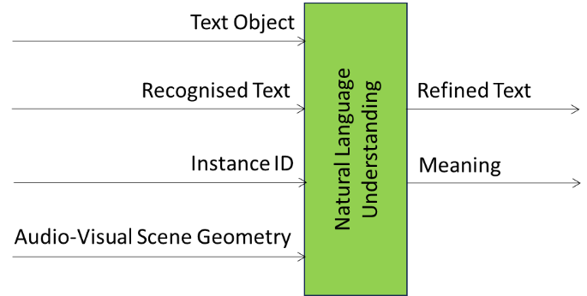
Figure 4 - Natural Language Understanding

Attributes
A Profile is determined by whether the AIM uses one or more of the following attributes:

Attribute | Code | Function
Text Object | TXO | MMC-NLU receives Text directly from human.
Recognised Text | TXR | MMC-NLU receives text from ASR.
Object Instance ID | OII | MMC-NLU receives Object Instance ID
Audio-Visual Scene Geometry | AVG | MMC-NLU receives AV Geometry.
Text Descriptors | TXD | MMC-NLU Produces Text Descriptors (Meaning)

Personal Status Extraction (MMC-PSE)

Definition
MMC-PSE
- Receives
  - Text information
    - Text Selector informs about availability of Text Descriptors
    - Text Object
    - Text Descriptors
  - Speech information
    - Speech Selector informs about availability of Speech Descriptors
    - Speech Object
    - Speech Descriptors
  - Face information informs about availability of Face Descriptors
    - Face Selector
    - Face Object
    - Face Descriptors
  - Body information
    - Gesture Selector informs about availability of Gesture Descriptors
    - Body Object
    - Gesture Descriptors
- Processes the received information
  - Computing the Modality (Text, Speech, Face, and Gesture) Descriptors for Cognitive State, Emotion and Social Attitude if Modality Selector signals that it is not already available.
  - Interpreting the Descriptors to produce the Personal Statuses of the Modalities.
  - Multiplexing the Personal Statuses of the Modalities into the Personal Status.
- Produces Personal Status.
- Enables the Entity Dialogue Processing to improve its ability to respond.

Specification
MMC-PSE is specified at [4.3].

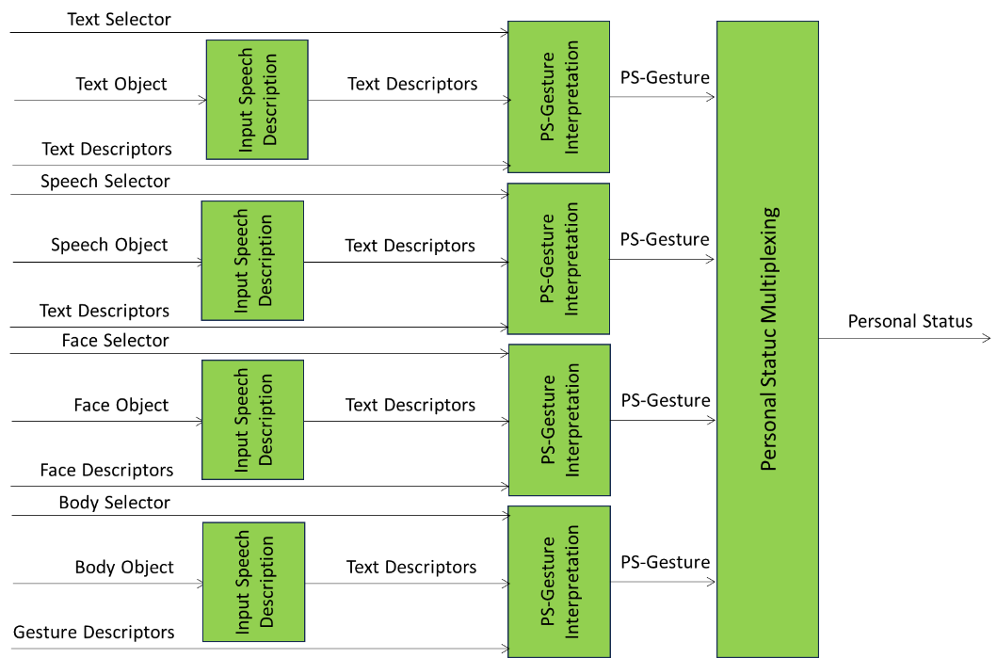
Figure 5 - Personal Status Extraction

Attributes
A PSE AIM Profile is determined by whether the AIM uses one or more of the following Attributes:

Attribute | Code | Function
Text Object | TXO | MMC-PSE receives Text
Speech Object | SPO | MMC-PSE receives Speech
Face Object | FCO | MMC-PSE receives Face
Body Object | BDO | MMC-PSE receives Gesture

When an MMC-PSE is used as a component AIM in a Composite AIM as in the case of HMC-ECU, the MMC-PSE Attributes become Sub-Attributes of the Composite AIM.

Text and Speech Translation (MMC-TST)

Definition
MMC-TST
- Receives:
  - Selector to inform whether
    - The AIM output should be Text or Speech.
    - The output Speech should retain the Features of the input Speech.
  - Language Preferences in the form of requested input and output language.
  - Personal Status.
  - Text.
  - Speech.
- Performs (a subset of) the following:
  - Converts input Speech into Text using Personal Status.
  - Translates the Text to the target language
  - Extracts the Features from Speech.
  - Converts Text into Speech adding the Speech Features.
- Produces:
  - Translated Text
  - Translated Speech

Specification
MMC-TST is specified at [4.4].

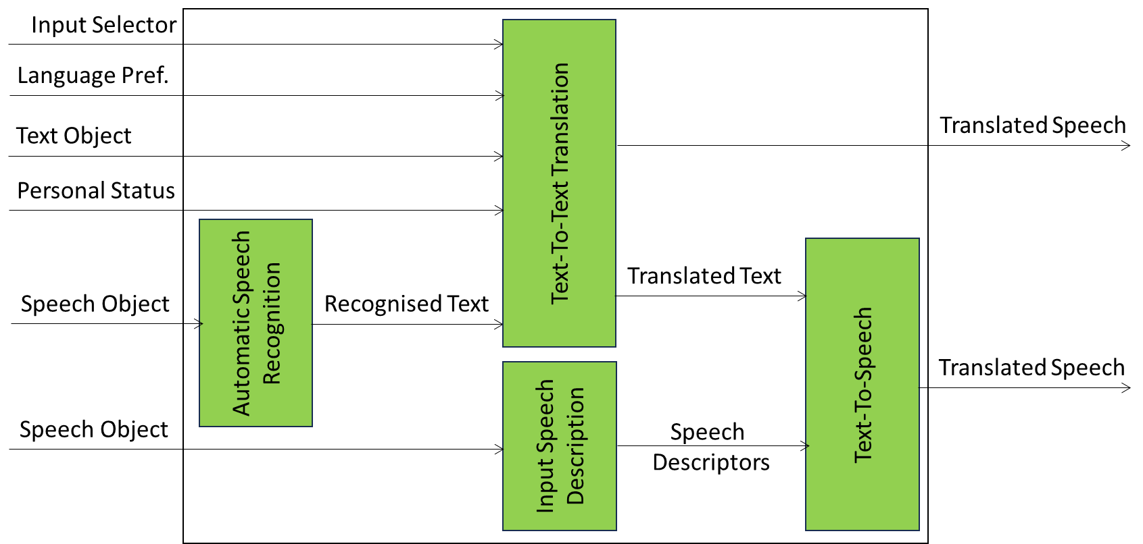
Figure 6 - Text and Speech Translation

Attributes
An MMC-TST AIM Profile is determined by whether the AIM uses one or more of the following Attributes:

Attributes | Code | Functions
Language Preferences | LGP | MMC-TST receives information on input and output languages.
Text Object | TXO | MMC-TST receives Text
Speech Object | SPO | MMC-TST receives Speech
Speech Descriptors | SPD | MMC-TST uses Speech Descriptors
Personal Status | IPS | MMC-TST receives Personal Status

When an MMC-TST is used as a component AIM in a Composite AIM as in the case of HMC-ECU, the LGP (Language Preferences) Attribute of MMC-TST become Sub-Attributes of the Composite AIM represented as 3-letter codes of [6], Part 3.

Audio-Visual Scene Rendering (PAF-AVR)

Definition
PAF-AVR
- Receives
  - Audio-Visual Scene Descriptors or a Portable Avatar.
  - A Point of View.
- Transforms the Portable Avatar into Audio-Visual Scene Descriptors.
- Produces
  - Text included in the Portable Avatar.
  - Output Audio, the result of rendering the Audio Scene Descriptors from the Point of View.
  - Output Visual, the result of rendering the Visual Scene Descriptors from the Point of View.

Specification
PAF-AVR is specified at [5.1].

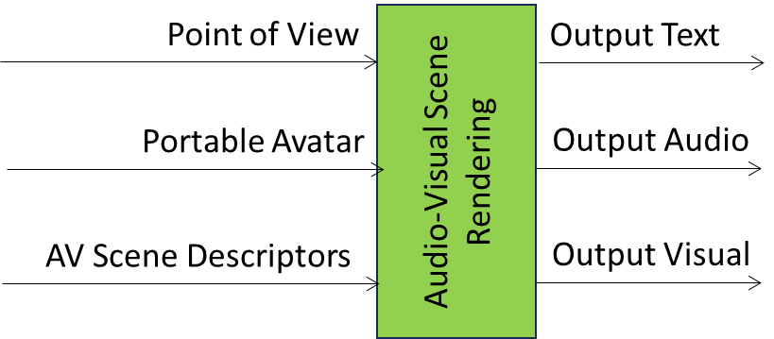

Figure 7 - Audio-Visual Scene Rendering

Attributes
A PAF-AVR AIM Profile is determined by whether the AIM uses one or more of the following attributes:

Attribute | Code | Function
Point of View | POV | PAF-AVR is informed to provide Output Audio and/or Output Visual as perceived from a Point of View.
Portable Avatar | PAV | PAF-AVR receives a Portable Avatar and produces an Audio-Visual Scene from the Point of View.
Audio-Visual Scene Descriptors | AVS | PAF-AVR receives Audio-Visual Scene Descriptors and produces an Audio-Visual Scene from the Point of View.
Output Text | TXO | PAF-AVR produces Text Object.
Output Audio | AUO | PAF-AVR produces Audio Object.
Output Visual | VIO | PAF-AVR produces Visual Object.

Personal Status Display (PAF-PSD)

Definition
PAF-PSD
- Receives
  - Text Object
  - Personal Status
  - Avatar Model
  - Speech Model
  - NN Format
- Uses
  - Text and PS-Speech to produce the Machine Speech.
  - Machine Speech, Avatar Model, and PS-Face to produce Machine Face Descriptors.
  - Machine Text, Avatar Model, and PS-Gesture to produce Machine Body Descriptors
- Produces Portable Avatar.
- Enables PAF-AVR to render the Portable Avatar produced by PAF-PSD.

Specification
PAF-PSD is specified at [5.2].

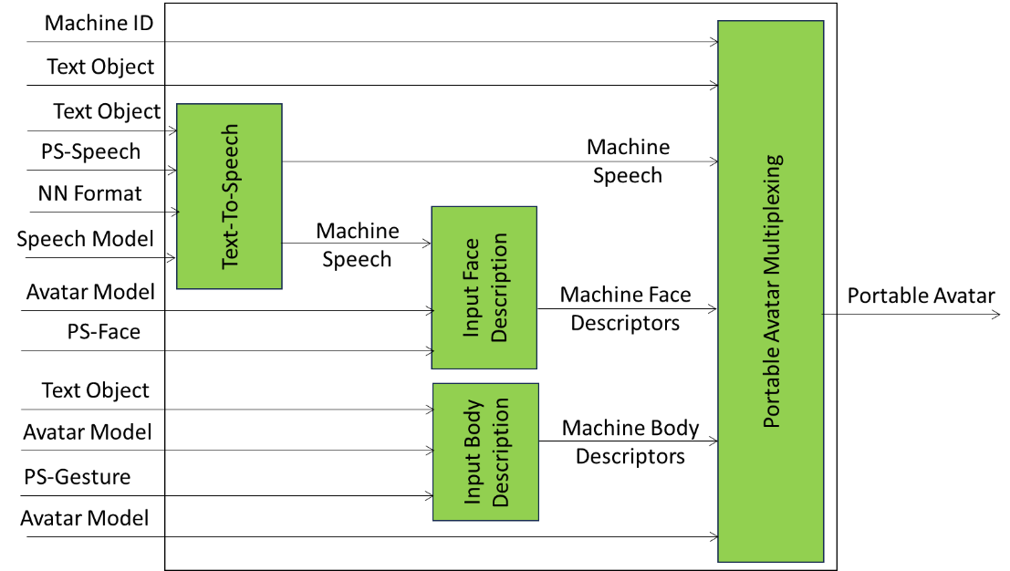
Figure 8 - Personal Status Display

Attributes
A PAF-PSD AIM Profile is determined by whether the AIM uses one or more of the following Attributes:

Attribute | Code | Function
Text Object | TXO | PAF-PSD receives Text and produces Speech.
Personal Status | IPS | PAF-PSD receives Personal Status.
Speech Model | SPM
Avatar Model | AVM | PAF-PSD receives an Avatar Model.

Text-to-Speech (MMC-TTS)

Definition
MMC-TTS
- Receives
  - Text Object.
  - Personal Status.
  - Speech Model.
- Feeds Text Object and Personal Status to Speech Model.
- Produces an utterance.

Specification
MMC-TTS is specified at [4.5].

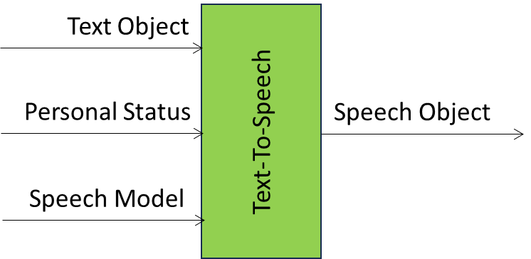
Figure 9 - Text-To-Speech

Attributes
An MMC-TTS AIM Profile is determined by whether the AIM uses one or more of the following Attributes:

Attribute | Code | Function
Text Object | TXO | MMC-TTS receives Text Object
Personal Status | IPS | MMC-TTS receives Personal Status
Speech Model | SPM | MMC-TTS receives NN Speech Model

- Notices and Disclaimers Concerning MPAI Standards (Informative)

The notices and legal disclaimers given below shall be borne in mind when downloading and using approved MPAI Standards.

In the following, “Standard” means the collection of four MPAI-approved and published documents: “Technical Specification”, “Reference Software” and “Conformance Testing” and, where applicable, “Performance Testing”.

Life cycle of MPAI Standards
MPAI Standards are developed in accordance with the MPAI Statutes. An MPAI Standard may only be developed when a Framework Licence has been adopted. MPAI Standards are developed by especially established MPAI Development Committees who operate on the basis of consensus, as specified in Annex 1 of the MPAI Statutes. While the MPAI General Assembly and the Board of Directors administer the process of the said Annex 1, MPAI does not independently evaluate, test, or verify the accuracy of any of the information or the suitability of any of the technology choices made in its Standards.

MPAI Standards may be modified at any time by corrigenda or new editions. A new edition, however, may not necessarily replace an existing MPAI standard. Visit the web page to determine the status of any given published MPAI Standard.

Description on MPAI Standards are welcome from any interested parties, whether MPAI members or not. Comments shall mandatorily include the name and the version of the MPAI Standard and, if applicable, the specific page or line the comment applies to. Comments should be sent to the MPAI Secretariat. Comments will be reviewed by the appropriate committee for their technical relevance. However, MPAI does not provide interpretation, consulting information, or advice on MPAI Standards. Interested parties are invited to join MPAI so that they can attend the relevant Development Committees.

Coverage and Applicability of MPAI Standards
MPAI makes no warranties or representations concerning its Standards, and expressly disclaims all warranties, expressed or implied, concerning any of its Standards, including but not limited to the warranties of merchantability, fitness for a particular purpose, non-infringement etc. MPAI Standards are supplied “AS IS”.

The existence of an MPAI Standard does not imply that there are no other ways to produce and distribute products and services in the scope of the Standard. Technical progress may render the technologies included in the MPAI Standard obsolete by the time the Standard is used, especially in a field as dynamic as AI. Therefore, those looking for standards in the Data Compression by Artificial Intelligence area should carefully assess the suitability of MPAI Standards for their needs.

IN NO EVENT SHALL MPAI BE LIABLE FOR ANY DIRECT, INDIRECT, INCIDENTAL, SPECIAL, EXEMPLARY, OR CONSEQUENTIAL DAMAGES (INCLUDING, BUT NOT LIMITED TO: THE NEED TO PROCURE SUBSTITUTE GOODS OR SERVICES; LOSS OF USE, DATA, OR PROFITS; OR BUSINESS INTERRUPTION) HOWEVER CAUSED AND ON ANY THEORY OF LIABILITY, WHETHER IN CONTRACT, STRICT LIABILITY, OR TORT (INCLUDING NEGLIGENCE OR OTHERWISE) ARISING IN ANY WAY OUT OF THE PUBLICATION, USE OF, OR RELIANCE UPON ANY STANDARD, EVEN IF ADVISED OF THE POSSIBILITY OF SUCH DAMAGE AND REGARDLESS OF WHETHER SUCH DAMAGE WAS FORESEEABLE.

MPAI alerts users that practicing its Standards may infringe patents and other rights of third parties. Submitters of technologies to this standard have agreed to licence their Intellectual Property according to their respective Framework Licences.

Users of MPAI Standards should consider all applicable laws and regulations when using an MPAI Standard. The validity of Conformance Testing is strictly technical and refers to the correct implementation of the MPAI Standard. Moreover, positive Performance Assessment of an implementation applies exclusively in the context of the MPAI Governance and does not imply compliance with any regulatory requirements in the context of any jurisdiction. Therefore, it is the responsibility of the MPAI Standard implementer to observe or refer to the applicable regulatory requirements. By publishing an MPAI Standard, MPAI does not intend to promote actions that are not in compliance with applicable laws, and the Standard shall not be construed as doing so. In particular, users should evaluate MPAI Standards from the viewpoint of data privacy and data ownership in the context of their jurisdictions.

Implementers and users of MPAI Standards documents are responsible for determining and complying with all appropriate safety, security, environmental and health and all applicable laws and regulations.

Copyright
MPAI draft and approved standards, whether they are in the form of documents or as web pages or otherwise, are copyrighted by MPAI under Swiss and international copyright laws. MPAI Standards are made available and may be used for a wide variety of public and private uses, e.g., implementation, use and reference, in laws and regulations and standardisation. By making these documents available for these and other uses, however, MPAI does not waive any rights in copyright to its Standards. For inquiries regarding the copyright of MPAI standards, please contact the MPAI Secretariat.

The Reference Software of an MPAI Standard is released with the MPAI Modified Berkeley Software Distribution licence. However, implementers should be aware that the Reference Software of an MPAI Standard may reference some third party software that may have a different licence.

- General MPAI Terminology
The capitalised Terms used in this standard that are not already included in Table 1are defined in Table 5.

NOTE: A hyphenated entry for e.g., “- Testing” should be read as adding that word to the closest non-hyphenated entry above it – in this case, “Conformance,” giving “Conformance Testing” as the complete entry name.

Table 5 – Terms used across several MPAI Technical Specifications
Term | Definition
Access | Static or slowly changing data that are required by an application such as domain knowledge data, data models, etc.
AI Framework (AIF) | The environment where AIWs are executed.
AI Model (AIM) | A data processing element receiving AIM-specific Inputs and producing AIM-specific Outputs according to according to its Function. An AIM may be an aggregation of AIMs.
AI Workflow (AIW) | A structured aggregation of AIMs implementing a Use Case receiving AIW-specific inputs and producing AIW-specific outputs according to the AIW Function.
Application Standard | An MPAI Standard designed to enable a particular application domain.
Assessment Laboratory | A laboratory accredited to Assess the Grade of Performance of Implementations.
Channel | A connection between an output port of an AIM and an input port of an AIM. The term “connection” is also used as synonymous.
Communication | The infrastructure that implements message passing between AIMs.
Component | One of the 7 AIF elements: Access, Communication, Controller, Internal Storage, Global Storage, Store, and User Agent
Composite AIM | An AIM aggregating more than one AIM.
Component | One of the 7 AIF elements: Access, Communication, Controller, Internal Storage, Global Storage, Store, and User Agent
Conformance | The attribute of an Implementation of being a correct technical Implementation of a Technical Specification.
- Testing | The normative document specifying the Means to Test the Conformance of an Implementation.
- Testing Dataset | A dataset used to Test the Conformance of an implementation to a Technical Specification.
- Testing Means | Procedures, tools, data sets and/or data set characteristics to Test the Conformance of an Implementation.
- Testing Procedure | The sequence of steps to be performed to Test the Conformance of an implementation.
- Testing Tools | Devices and/or software used to Test the Conformance of an implementation.
Connection | A channel connecting an output port of an AIM and an input port of an AIM.
Controller | A Component that manages and controls the AIMs in the AIF, so that they execute in the correct order and at the time when they are needed
Data | Information in digital form.
- Format | The standard digital representation of Data.
- Type | An instance of Data with a specific Data Format.
- Semantics | The meaning of Data.
Descriptor | Coded representation of a text, audio, speech, or visual feature.
Digital Representation | Data corresponding to and representing a physical entity.
Ecosystem | The ensemble of actors making it possible for a User to execute an application composed of an AIF, one or more AIWs, each with one or more AIMs potentially sourced from independent implementers.
Explainability | The ability to trace the output of an Implementation back to the inputs that have produced it.
Fairness | The attribute of an Implementation whose extent of applicability can be assessed by making the training set and/or network open to testing for bias and unanticipated results.
Function | The operations effected by an AIW or an AIM on input data.
Global Storage | A Component to store data shared by AIMs.
AIM/AIW Storage | A Component to store data of the individual AIMs.
Identifier | A name that uniquely identifies an Implementation.
Implementation | - An embodiment of the MPAI-AIF Technical Specification, or  - An AIW or AIM of a particular Level (1-2-3) conforming with a Use Case of an MPAI Application Standard.
Implementer | A legal entity implementing MPAI Technical Specifications.
ImplementerID (IID) | A unique name assigned by the ImplementerID Registration Authority to an Implementer.
ImplementerID Registration Authority (IIDRA) | The entity appointed by MPAI to assign ImplementerID’s to Implementers.
Instance ID | Instance of a class of Objects and the Group of Objects the Instance belongs to.
Interoperability | The ability to functionally replace an AIM with another AIW having the same Interoperability Level
- Level | The attribute of an AIW and its AIMs to be executable in an AIF Implementation and to:  - Be proprietary (Level 1)  - Pass the Conformance Testing (Level 2) of an Application Standard  - Pass the Performance Testing (Level 3) of an Application Standard.
Knowledge Base | Structured and/or unstructured information made accessible to AIMs via MPAI-specified interfaces
Message | A sequence of Records transported by Communication through Channels.
Normativity | The set of attributes of a technology or a set of technologies specified by the applicable parts of an MPAI standard.
Performance | The attribute of an Implementation of being Reliable, Robust, Fair and Replicable.
- Assessment | The normative document specifying the Means to Assess the Grade of Performance of an Implementation.
- Assessment Means | Procedures, tools, data sets and/or data set characteristics to Assess the Performance of an Implementation.
- Assessor | An entity Assessing the Performance of an Implementation.
Profile | A particular subset of the technologies used in MPAI-AIF or an AIW of an Application Standard and, where applicable, the classes, other subsets, options and parameters relevant to that subset.
Record | A data structure with a specified structure
Reference Model | The AIMs and theirs Connections in an AIW.
Reference Software | A technically correct software implementation of a Technical Specification containing source code, or source and compiled code.
Reliability | The attribute of an Implementation that performs as specified by the Application Standard, profile, and version the Implementation refers to, e.g., within the application scope, stated limitations, and for the period of time specified by the Implementer.
Replicability | The attribute of an Implementation whose Performance, as Assessed by a Performance Assessor, can be replicated, within an agreed level, by another Performance Assessor.
Robustness | The attribute of an Implementation that copes with data outside of the stated application scope with an estimated degree of confidence.
Scope | The domain of applicability of an MPAI Application Standard
Service Provider | An entrepreneur who offers an Implementation as a service (e.g., a recommendation service) to Users.
Standard | A set of Technical Specification, Reference Software, Conformance Testing, Performance Assessment, and Technical Report of an MPAI application Standard.
Technical Specification | (Framework) the normative specification of the AIF.  (Application) the normative specification of the set of AIWs belonging to an application domain along with the AIMs required to Implement the AIWs that includes:  - The formats of the Input/Output data of the AIWs implementing the AIWs.  - The Connections of the AIMs of the AIW.  - The formats of the Input/Output data of the AIMs belonging to the AIW.
Time Base | The protocol specifying how Components can access timing information
Topology | The set of AIM Connections of an AIW.
Use Case | A particular instance of the Application domain target of an Application Standard.
User | A user of an Implementation.
User Agent | The Component interfacing the user with an AIF through the Controller
Version | A revision or extension of a Standard or of one of its elements.
Zero Trust | A cybersecurity model primarily focused on data and service protection that assumes no implicit trust.

- Patent Declarations
Technical Specification: AI Module Profiles has been developed using four MPAI Technical Specifications: MPAI-CAE, MPAI-HMC, MPAI-MMC, MPAI-OSD, and MPAI-PAF. While the AIM Profile identification method has been originally developed by MPAI and is freely available, the data types referenced by the MPAI-PRF Technical Specification may be affected by the Patent Coverage of the relevant Technical Specifications.

