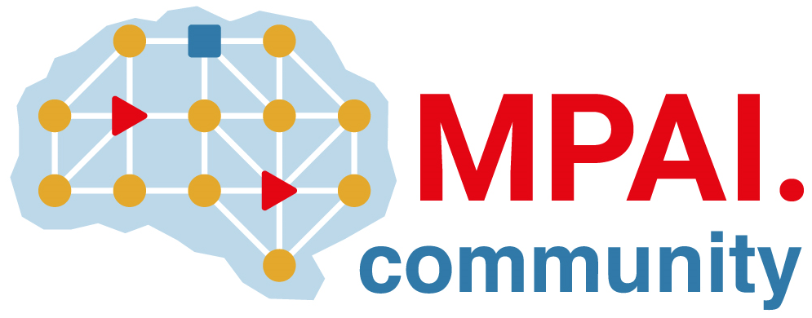 | Moving Picture, Audio and Data Coding by Artificial Intelligence  www.mpai.community

Public document
N1735 | 2024/04/17
Source | Requirements (EEV)
Title | Requirements (EEV) progress report and plans
Target | MPAI-43

Requirements (EEV) has made significant progress in learned video coding and there are four major versions of reference software. The EEV group has made a practical step in preparing the draft to standardize a neural video codec.

The EEV group has planned its first document (WD0.1) towards the call for technologies (CfT). The train and evaluation conditions and associated procedures are defined and refined. In addition, the reference model (EEV-0.5 model) development is also continuing, the BD-rate performance (PSNR-based) are 2% better than last month.

