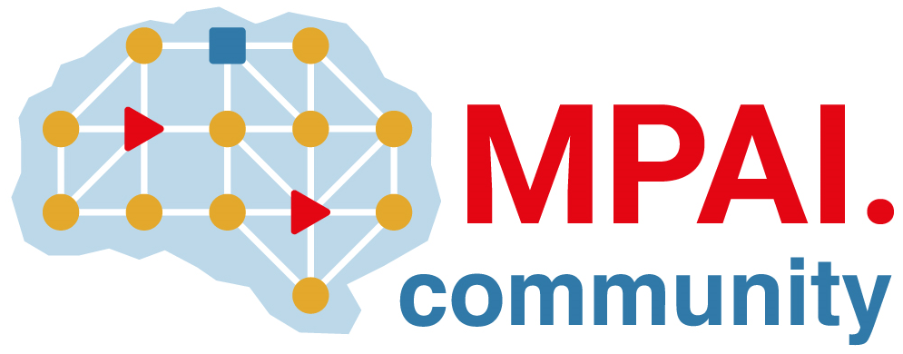 | Moving Picture, Audio and Data Coding by Artificial Intelligence  www.mpai.community

Public document
N1862 | 2024/07/10
Source | 46th MPAI General Assembly (MPAI-46)
Title | MPAI-46 Press Release
Target | MPAI-46

MPAI publishes Version 1.1 of the
Human and Machine Communication standard

Geneva, Switzerland – 10 July 2024. MPAI – Moving Picture, Audio and Data Coding by Artificial Intelligence – the international, non-profit, and unaffiliated organisation developing AI-based data coding standards has concluded its 46th General Assembly (MPAI-46) by approving for publication the new Version 1.1 of the Human and Machine Communication standard.

Technical Specification: Human and Machine Communication (MPAI-HMC) V1.1 enables an Entity to hold a multimodal communication with another Entity possibly in a different Context. The standard is agnostic of the parties in a communication as an Entity can be a human in an audio-visual scene of a real space or a Machine in an Audio-Visual Scene of a Virtual Space. Humans and Machines can operate in different Contexts, e.g., language and culture. MPAI-HMC references a range of technologies specified in five MPAI Standards.

MPAI-HMC will be presented online on 22 July at 15 UTC (8 PDT, 11 EDT, 23 CST, 24 KST). To attend the presentation, register at https://us06web.zoom.us/meeting/register/tZEtde-orTwqE9x9sSkauN9CxKsLvbJrIeSF.

At previous meetings, MPAI has published four draft standards for Community Comments: Context-base Audio Enhancement V2.2, Multimodal Conversation V2.2, Object and Scene Description V1.1, and Portable Avatar Format V1.2. Interested parties should check the mentioned links and make comments as the deadline for submission has not been reached yet.

MPAI is continuing its work plan that involves the following activities:
- AI Framework (MPAI-AIF): developing open-source applications based on the AI Framework.
- AI for Health (MPAI-AIH): developing the specification of a system enabling clients to improve models processing health data and federated learning to share the training.
- Context-based Audio Enhancement (CAE-DC): preparing new projects.
- Connected Autonomous Vehicle (MPAI-CAV): Functional Requirements of the data used by the MPIA-CAV – Architecture standard.
- Compression and Understanding of Industrial Data (MPAI-CUI): preparation for an extension to existing standard that includes support for more corporate risks.
- End-to-End Video Coding (MPAI-EEV): video coding using AI-based End-to-End Video coding.
- AI-Enhanced Video Coding (MPAI-EVC). video coding with AI tools added to existing tools.
- Human and Machine Communication (MPAI-HMC): developing reference software.
- Multimodal Conversation (MPAI-MMC): developing reference software and exploring new areas.
- MPAI Metaverse Model (MPAI-MMM): developing reference software specification and identifying metaverse technologies requiring standards.
- Neural Network Watermarking (MPAI-NNW): developing reference software for enhanced applications.
- Portable Avatar Format (MPAI-PAF): developing reference software, conformance testing and new areas for digital humans.
- AI Module Profiles (MPAI-PRF): to specify which features an AI Module supports.
- Server-based Predictive Multiplayer Gaming (MPAI-SPG): developing technical report on mitigation of data loss and cheating.
- XR Venues (MPAI-XRV): developing the standard enabling improved development and execution of Live Theatrical Performance.

Legal entities and representatives of academic departments supporting the MPAI mission and able to contribute to the development of standards for the efficient use of data can become MPAI members.

Please visit the MPAI website, contact the MPAI secretariat for specific information, subscribe to the MPAI Newsletter and follow MPAI on social media: LinkedIn, Twitter, Facebook, Instagram, and YouTube.

