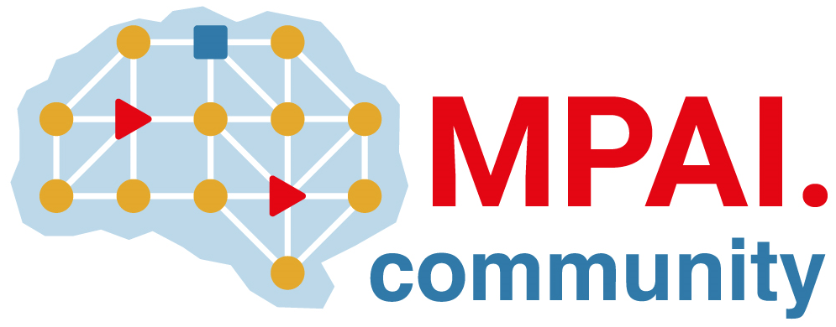 | Moving Picture, Audio and Data Coding  by Artificial Intelligence  www.mpai.community

Public document
N1998 | 2024/09/30
Source | Requirements (EEV)
Title | MPAI-EEV Progress report and plans
Target | MPAI-48

The group has continued the development of MPAI-EEV V0.5

