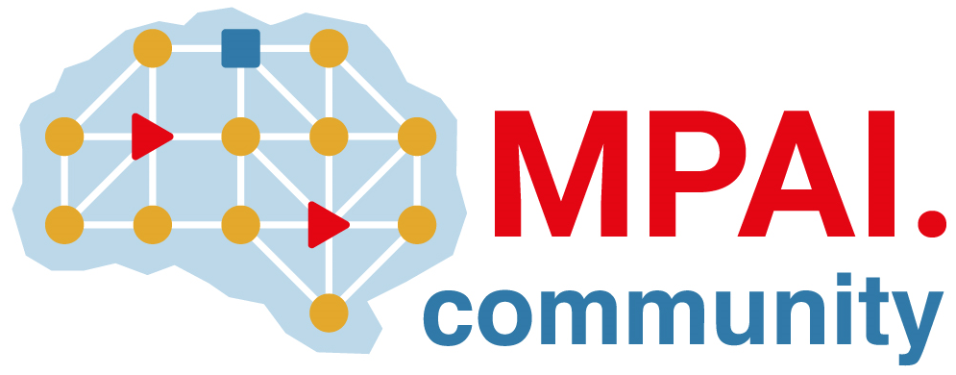 | Moving Picture, Audio and Data Coding by Artificial Intelligence  www.mpai.community

Public document
N2008 | 2024/10/23
Source | 49th MPAI General Assembly (MPAI-49)
Title | MPAI-49 Press Release
Target | MPAI-49

MPAI addresses signalling of Machine Learning Model compliance

Geneva, Switzerland – 23rd October 2024. MPAI – Moving Picture, Audio and Data Coding by Artificial Intelligence – the international, non-profit, and unaffiliated organisation developing AI-based data coding standards – has concluded its 49th General Assembly (MPAI-49) by approving for publication with a request for community comments:
- Technical Specification: AI Framework (MPAI-AIF) V2.1
- Technical Specification: Data Types, Formats, and Attributes (MPAI-TFA) V1.2

Technical Specification: AI Framework (MPAI-AIF) V2.1 includes a specification of the Machine Learning Model Data Type and refers to Technical Specification: Data Types, Formats, and Attributes (MPAI-TFA) V1.2 providing a specification of Machine Learning Model Qualifier (MPAI-TFA) V1.2. This enables the signalling of compliance of a Machine Learning Model to a particular regulation out of a list, its certification status, and the validity of the data. Both drafts are published for Community Comments to be received by the MPAI secretariat by 2024/11/16 T23:59.

Technical Specification: Data Types, Formats, and Attributes (MPAI-TFA) V1.1 previously published for Community Comments is now a regular MPAI standard enabling the signalling of Formats and Attributes of Data Types related to media and metaverse.

MPAI is continuing its work plan that involves the following activities:
- AI Framework (MPAI-AIF): building a community of MPAI-AIF-based implementers.
- AI for Health (MPAI-AIH): developing the specification of a system enabling clients to improve models processing health data and federated learning to share the training.
- Context-based Audio Enhancement (CAE-DC): developing the Audio Six Degrees of Freedom (CAE-6DF) standard.
- Connected Aonomous Vehicle (MPAI-CAV): updating the MPAI-CAV Architecture part developing the new MPAI-CAV Technologies (CAV-TEC) part of the standard.
- Compression and Understanding of Industrial Data (MPAI-CUI): developing use cases and functional requirements for MPAI-CUI V2.0 supporting a wide range of corporate risks.
- End-to-End Video Coding (MPAI-EEV): video coding using AI-based End-to-End Video coding.
- Governance of the MPAI Ecosystem (MPAI-GME): working on version 2.0 of the Specification.
- Human and Machine Communication (MPAI-HMC): developing reference software.
- Multimodal Conversation (MPAI-MMC): Developing technologies for more Natural-Language-based user interfaces capable of handling more complex questions.
- MPAI Metaverse Model (MPAI-MMM): extending the MPAI-MMM specs to support more applications.
- Neural Network Watermarking (MPAI-NNW): studying the use of fingerprinting as a technology for neural network traceability.
- Object and Scene Description (MPAI-PAF): studying applications requiring more space-time handling applications.
- Portable Avatar Format (MPAI-PAF): studying more applications using digital humans needing new technologies.
- AI Module Profiles (MPAI-PRF): specifying which features AI Workflow or more AI Modules need to support.
- Server-based Predictive Multiplayer Gaming (MPAI-SPG): developing technical report on mitigation of data loss.
- Data Types, Formats, and Attribes (MPAI-TFA) extending the standard to data types used by MPAI standards (e.g., aomotive and health).
- AI-Enhanced Video Coding (MPAI-EVC): working toward the publication of Call for Technologies for video up-sampling filter.
- XR Venues (MPAI-XRV): developing the standard for improved development and execion of Live Theatrical Performances and studying the prospects of Cillaborative Immersive Laboratories.

Legal entities and representatives of academic departments supporting the MPAI mission and able to contribute to the development of standards for the efficient use of data can become MPAI members.

Please visit the MPAI website, contact the MPAI secretariat for specific information, subscribe to the MPAI Newsletter and follow MPAI on social media: LinkedIn, Twitter, Facebook, Instagram, and Yoube.

