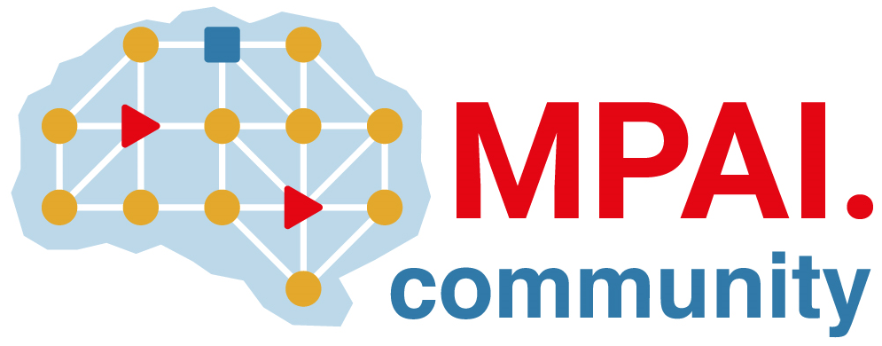 | Moving Picture, Audio and Data Coding by Artificial Intelligence  www.mpai.community

Public document
N2058 | 2024/11/20
Source | 50th MPAI General Assembly (MPAI-50)
Title | MPAI-50 Press Release
Target | MPAI-50

MPAI calls for “Up-sampling Filter for Video applications” technologies

Geneva, Switzerland – 21st November 2024. MPAI – Moving Picture, Audio and Data Coding by Artificial Intelligence – the international, non-profit, and unaffiliated organisation developing AI-based data coding standards – has concluded its 49th General Assembly (MPAI-49) by approving for publication
- Call for Technologies: Up-sampling Filter for Video applications (MPAI-UFV)
- Technical Specification: Neural Network Traceability *MPAI-NNT) V1.0
- Technical Specification: Human and Machine Communication (MPAI-HMC) V2.0
- New versions of four standards with added Conformance Testing

Call for Technologies: Up-sampling Filter for Video applications (MPAI-UFV) invites any party able and wishing to contribute to the development of the planned MPAI-UFV Technical Specification to submit a response. MPAI-UFV is expected to leverage AI to provide higher video quality when upsampling a video from Standard Definition to HDTV and from HDTV to 4K.

Technical Specification: Neural Network Traceability (MPAI-NNT) V1.0 specifies methods to evaluate the ability to trace back to its source a neural network that has been modified, the computational cost of injecting, extracting, detecting, decoding, or matching data from a network, and the impact on a neural network with inserted traceability data and its inference on the performance.

Technical Specification: Human and Machine Communication (MPAI-HMC) V2.0 enable advanced forms of communication between humans in a real space or represented in a Virtual Space, and Machines represented as humanoids in a Virtual Space or rendered as humanoids in a real space. This new version leverages MPAI-CAE V2.3, MPAI MMC V2.3, MPAI-OSD V1.2, MPAI-PAF V1.3 and Technical Specification: Data Types, Formats, and Attributes (MPAI-TFA) V1.2 – just confirmed as an MPAI standard.

The Call and the standards will be presented online according to the schedule reported below.

Type | Register for presentation of | Code | Date/Time (UTC)
Call for Tech. | Upsampling Filter for Video application | UFV | 2024/11/27T14
New Standard | Neural Network Traceability | NNT | 2024/12/10T15
Revised Standard | Human and Machine Communication | HMC | 2024/12/09T16

MPAI is continuing its work plan that involves the following activities:
- AI Framework (MPAI-AIF): building a community of MPAI-AIF-based implementers.
- AI for Health (MPAI-AIH): developing the specification of a system enabling clients to improve models processing health data and federated learning to share the training.
- Context-based Audio Enhancement (CAE-DC): developing the Audio Six Degrees of Freedom (CAE-6DF) standard.
- Connected Aonomous Vehicle (MPAI-CAV): updating the MPAI-CAV Architecture part developing the new MPAI-CAV Technologies (CAV-TEC) part of the standard.
- Compression and Understanding of Industrial Data (MPAI-CUI): developing use cases and functional requirements for MPAI-CUI V2.0 supporting a wide range of corporate risks.
- End-to-End Video Coding (MPAI-EEV): video coding using AI-based End-to-End Video coding.
- AI-Enhanced Video Coding (MPAI-EVC): waiting for responses to the Call for Technologies for video up-sampling filter.
- Governance of the MPAI Ecosystem (MPAI-GME): working on version 2.0 of the Specification.
- Human and Machine Communication (MPAI-HMC): developing reference software.
- Multimodal Conversation (MPAI-MMC): Developing technologies for more Natural-Language-based user interfaces capable of handling more complex questions.
- MPAI Metaverse Model (MPAI-MMM): extending the MPAI-MMM specs to support more applications.
- Neural Network Watermarking (MPAI-NNW): studying the use of fingerprinting as a technology for neural network traceability.
- Object and Scene Description (MPAI-PAF): studying applications requiring more space-time handling applications.
- Portable Avatar Format (MPAI-PAF): studying more applications using digital humans needing new technologies.
- AI Module Profiles (MPAI-PRF): specifying which features AI Workflow or more AI Modules need to support.
- Server-based Predictive Multiplayer Gaming (MPAI-SPG): developing technical report on mitigation of data loss.
- Data Types, Formats, and Attribes (MPAI-TFA) extending the standard to data types used by MPAI standards (e.g., aomotive and health).
- XR Venues (MPAI-XRV): developing the standard for improved development and execion of Live Theatrical Performances and studying the prospects of Cillaborative Immersive Laboratories.

Legal entities and representatives of academic departments supporting the MPAI mission and able to contribute to the development of standards for the efficient use of data can become MPAI members.

Please visit the MPAI website, contact the MPAI secretariat for specific information, subscribe to the MPAI Newsletter and follow MPAI on social media: LinkedIn, Twitter, Facebook, Instagram, and Yoube.

