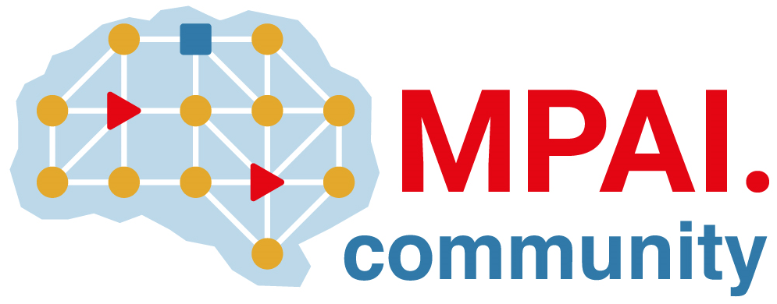 | Moving Picture, Audio and Data Coding by Artificial Intelligence  www.mpai.community

Public document
N2109 | 2024/12/18
Source | 51st MPAI General Assembly (MPAI-51)
Title | MPAI-51 Press Release
Target | MPAI-51

MPAI calls for “Company Performance Prediction” technologies

Geneva, Switzerland – 18th December 2024. MPAI – Moving Picture, Audio and Data Coding by Artificial Intelligence – the international, non-profit, unaffiliated organisation developing AI-based data coding standards – has concluded its 51st General Assembly (MPAI-51) approving publication of the Compression and Understanding of Industrial data (MPAI-CUI) V2.0 Call for Technologies.

Call for Technologies: Compression and Understanding of Industrial data (MPAI-CUI) V2.0 invites any party able and wishing to contribute to the development of the planned MPAI-CUI V2.0 Technical Specification to submit a response by 11th of February 2025. The new standard will extend the current company organisation index and default/discontinuity probabilities with descriptors and information on the compliance of the Machine Learning Models used.

MPAI-51 also approved as MPAI standards:
- Neural Network Traceability (MPAI-NNT) V1.0 to evaluate the ability to trace back to its source a neural network that has been modified, the computational cost of injecting, extracting, detecting, decoding, or matching data from a neural network, and the impact on the performance of a neural network with inserted traceability data and its inference.
- Human and Machine Communication (MPAI-HMC) V2.0 that enables advanced forms of communication between humans in a real space or represented in a Virtual Space, and Machines represented as humanoids in a Virtual Space or rendered as humanoids in a real space.
- Context-based Audio Enhancement (MPAI-CAE) V2.3, Multimodal Conversation (MPAI MMC) V2.3, Object and Scene Descriptors (MPAI-OSD) V1.2, and: Portable Avatar Format (MPAI-PAF) V1.3.

The MPAI-CUI V2.0 Call for Technologies will be presented online on 8th of January 2025 at 15 UTC. Register at https://tinyurl.com/4vdps8f3 to attend.

MPAI is continuing its work plan that involves the following activities:
- AI Framework (MPAI-AIF): building a community of MPAI-AIF-based implementers.
- AI for Health (MPAI-AIH): developing the specification of a system enabling clients to improve models processing health data and federated learning to share the training.
- Context-based Audio Enhancement (CAE-DC): developing the Audio Six Degrees of Freedom (CAE-6DF) standard.
- Connected Aonomous Vehicle (MPAI-CAV): updating the MPAI-CAV Architecture part and developing the new MPAI-CAV Technologies (CAV-TEC) part of the standard.
- Compression and Understanding of Industrial Data (MPAI-CUI): waiting for responses on 11 February.
- End-to-End Video Coding (MPAI-EEV): exploring the potential of video coding using AI-based End-to-End Video coding.
- AI-Enhanced Video Coding (MPAI-EVC): waiting for responses to the Call for Technologies for video up-sampling filter on 11 February.
- Governance of the MPAI Ecosystem (MPAI-GME): working on version 2.0 of the Specification.
- Human and Machine Communication (MPAI-HMC): developing reference software and performance assessment.
- Multimodal Conversation (MPAI-MMC): Developing technologies for more Natural-Language-based user interfaces capable of handling more complex questions.
- MPAI Metaverse Model (MPAI-MMM): extending the MPAI-MMM specs to support more applications.
- Neural Network Watermarking (MPAI-NNW): studying the use of fingerprinting as a technology for neural network traceability.
- Object and Scene Description (MPAI-PAF): studying applications requiring more space-time handling applications.
- Portable Avatar Format (MPAI-PAF): studying more applications using digital humans needing new technologies.
- AI Module Profiles (MPAI-PRF): specifying which features AI Workflow or more AI Modules need to support.
- Server-based Predictive Multiplayer Gaming (MPAI-SPG): developing technical report on mitigation of data loss.
- Data Types, Formats, and Attribes (MPAI-TFA) extending the standard to data types used by MPAI standards (e.g., aomotive and health).
- XR Venues (MPAI-XRV): developing the standard for improved development and execion of Live Theatrical Performances and studying the prospects of Collaborative Immersive Laboratories.

Legal entities and representatives of academic departments supporting the MPAI mission and able to contribute to the development of standards for the efficient use of data can become MPAI members.

Please visit the MPAI website, contact the MPAI secretariat for specific information, subscribe to the MPAI Newsletter and follow MPAI on social media: LinkedIn, Twitter, Facebook, Instagram, and Yoube.

