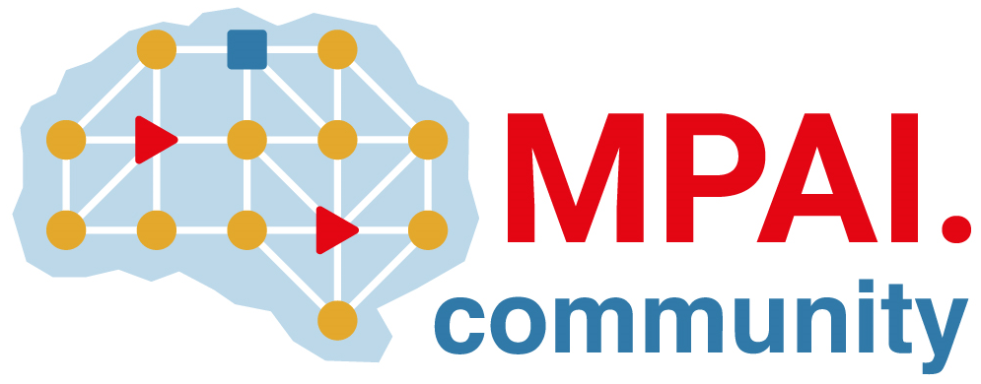 | Moving Picture, Audio and Data Coding by Artificial Intelligence  www.mpai.community

N2101 | 2024/11/20
Source | Requirements (EEV)
Title | Requirements (EEV) progress report and plans
Target | MPAI-50

Requirements (EEV) has made significant progress in learned video coding and there are four major versions of reference software. The EEV group has made a practical step in preparing the draft to standardize a neural video codec. Regarding the reference model development, the latetest reference model (EEV-0.5) has been finished and published. Moreover, some practical improvement and optimization are also conducting to further increase the coding efficiency. The EEV-0.6 is on its way. Some preliminary results have demonstrated that EEV-0.6 has better coding performance than VVC/H.266.

