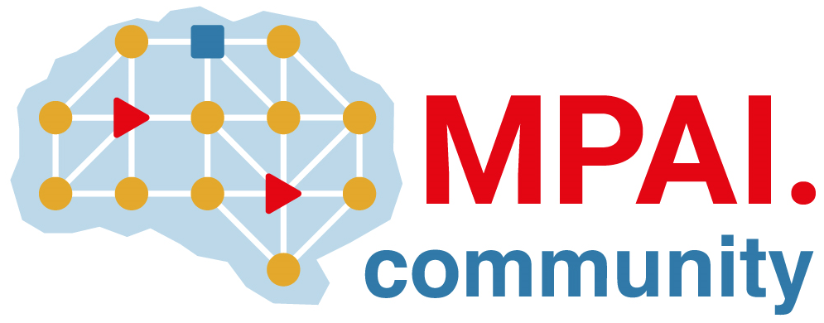 | Moving Picture, Audio and Data Coding  by Artificial Intelligence  www.mpai.community

Public document
N2182 | 2025/01/22
Source | Requirements (EVC)
Title | Requirements (EVC) Report and Plans
Target | MPAI-52

The group requests that the deadline for EVC-UFV be delayed by one meeting cycle.

