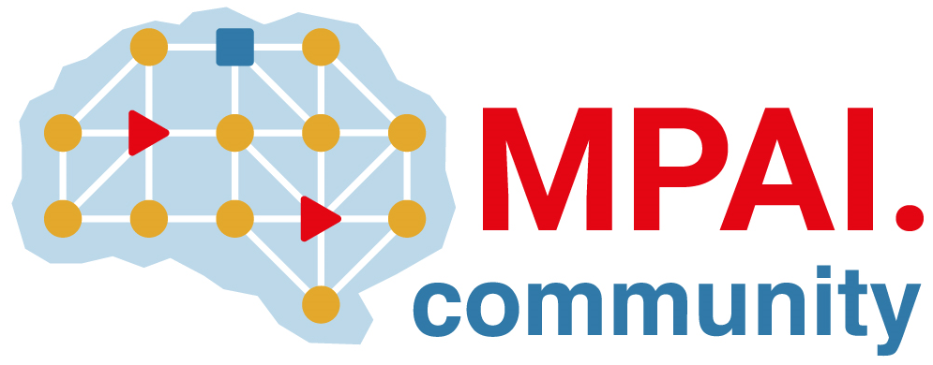 | Moving Picture, Audio and Data Coding by Artificial Intelligence  www.mpai.community

Public document
N2200 | 2025/01/22
Source | Requirements (EEV)
Title | Requirements (EEV) progress report and plans
Target | MPAI-52

Requirements (EEV) has made significant progress in learned video coding and there are four major versions of reference software. The EEV group has made a practical step in preparing the draft to standardize a neural video codec.

Regarding the reference model development, the EEV-0.6 is on under construction and still evolving. Some preliminary results have demonstrated that EEV-0.6 has better coding performance than VVC/H.266. Investigations are undertaken to further strength the coding performance.

