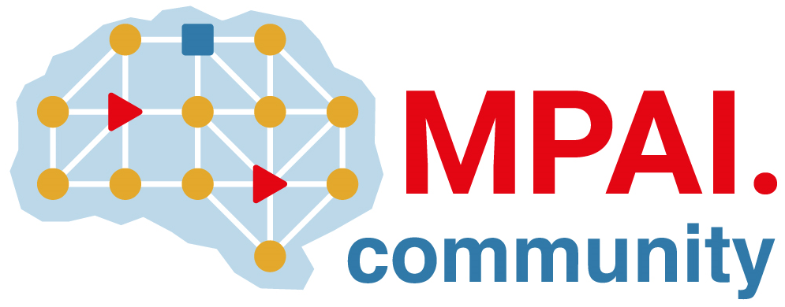 | Moving Picture, Audio and Data Coding  by Artificial Intelligence  www.mpai.community

Public document
N2227 | 2025/02/19
Source | Requirements (EVC)
Title | Requirements (EVC) Report and Plans
Target | MPAI-53

The group has issued Call for Technologies [1] and is currently preparing the test sequences to be provided to the proponents.

The team is working on coding the test sequences for the proponents (the proponents will use this sequence to demonstrate to MPAI the objective metrics specified in the CfT).
This task involves coding five sequences. The initial phase includes downscaling 4K sequences into HD and SD resolution and coding with various Quantization Parameters (QPs) - 22, 27, 32, 37, and 42. These sequences will be provided across three codecs: AVC, HEVC, and VVC, in both Random Access and Low Delay modes.
The complexity of this task is reflected in the numbers: 2 modes, 5 sequences, 5 QPs, 3 codecs, and 2 resolutions (SD and HD), resulting in a total of 300 test points.

Adding an element of confidentiality, an esteemed academic has selected 'secret' sequences for the MPAI test. The EVC members will utilize the proponents' software to encode these secret sequences, selecting a limited number of test points.

- Reference
[1] https://mpai.community/standards/mpai-evc/ufv/v1-0/call-for-technologies/

