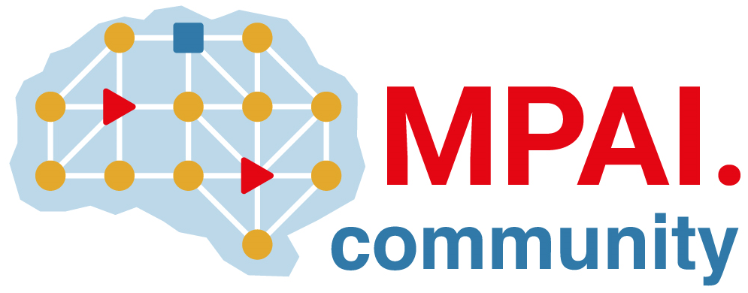 | Moving Picture, Audio and Data Coding by Artificial Intelligence  www.mpai.community

Public document
N2337 | 2025/05/14
Source | 56th MPAI General Assembly (MPAI-56)
Title | MPAI-56 Press Release
Target | MPAI-56

MPAI publishes AIW and AIM Implementation Guidelines
for Community Comments

Geneva, Switzerland – 14th May 2025. MPAI – Moving Picture, Audio and Data Coding by Artificial Intelligence – the international, non-profit, unaffiliated organisation developing AI-based data coding standards – has concluded its 56th General Assembly (MPAI-56) with the publication of the Technical Report: AIW and AIM Implementation Guidelines (MPAI-WMG) for Community Comments.

A significant share of MPAI standards rely on AI Framework (MPAI-AIF) that supports componentisation of processing elements called AI Modules (AIM) organised in an AI Framework. As AIMs are agnostic of the technologies used in their implementation – traditional data processing or various types of AI technologies, MPAI-WMG includes an analysis of a significant number of already specified AIMs from the implementation perspective. MPAI-WMG also includes an analysis of the use of the Perceptive and Agentive AI (PAAI) Model that may provide a new basis for new forms of AI Frameworks.

MPAI is continuing its work plan that involves the following activities:
- AI Framework (MPAI-AIF): building a community of MPAI-AIF-based implementers.
- AI for Health (MPAI-AIH): developing the specification of a system enabling clients to improve models processing health data and federated learning to share the training.
- Context-based Audio Enhancement (CAE-DC): developing the Audio Six Degrees of Freedom (CAE-6DF) standard.
- Connected Autonomous Vehicle (MPAI-CAV): investigating extensions of the current CAV-TEC standard.
- Compression and Understanding of Industrial Data (MPAI-CUI): developing Company Performance Prediction standard V2.0.
- End-to-End Video Coding (MPAI-EEV): exploring the potential of video coding using AI-based End-to-End Video coding.
- AI-Enhanced Video Coding (MPAI-EVC): developing the Up-sampling Filter for Video applications (EVC-UFV) standard.
- Governance of the MPAI Ecosystem (MPAI-GME): working on version 2.0 of the Specification.
- Human and Machine Communication (MPAI-HMC): developing reference software and performance assessment.
- Multimodal Conversation (MPAI-MMC): Developing technologies for more Natural-Language-based user interfaces capable of handling more complex questions.
- MPAI Metaverse Model (MPAI-MMM): extending the MMM-TEC specs to support more applications.
- Neural Network Watermarking (MPAI-NNW): studying the use of fingerprinting as a technology for neural network traceability.
- Object and Scene Description (MPAI-PAF): studying applications requiring more space-time handling applications.
- Portable Avatar Format (MPAI-PAF): studying more applications using digital humans needing new technologies.
- AI Module Profiles (MPAI-PRF): specifying which features AI Workflow or more AI Modules need to support.
- Server-based Predictive Multiplayer Gaming (MPAI-SPG): exploring new standard opportunities in the domain.
- Data Types, Formats, and Attribes (MPAI-TFA) extending the standard to data types used by MPAI standards (e.g., aomotive and health).
- XR Venues (MPAI-XRV): developing the standard for improved development and execion of Live Theatrical Performances and studying the prospects of Collaborative Immersive Laboratories.

Legal entities and representatives of academic departments supporting the MPAI mission and able to contribute to the development of standards for the efficient use of data can become MPAI members.

Please visit the MPAI website, contact the MPAI secretariat for specific information, subscribe to the MPAI Newsletter and follow MPAI on social media: LinkedIn, Twitter, Facebook, Instagram, and YouTube.

