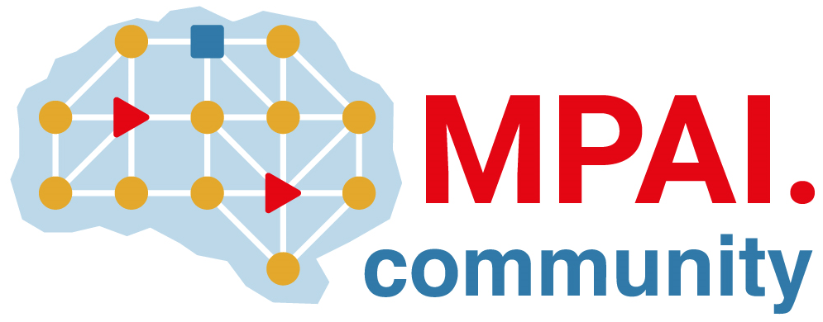 | Moving Picture, Audio and Data Coding by Artificial Intelligence  www.mpai.community

Public document
N2434 | 2025/06/11
Source | Requirements (EEV)
Title | Requirements (EEV) progress report and plans
Target | MPAI-57

Requirements (EEV) has made significant progress in learned video coding and there are five versions of reference software. The EEV group has made a practical step in preparing the draft to standardize a neural video codec.

Regarding the reference model development, the EEV-0.6 has proposed something new on the top of the previous version. Some recent published papers and models are reviewed.

