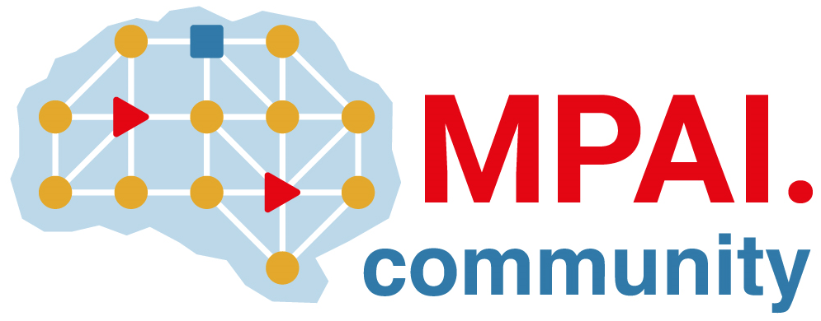 | Moving Picture, Audio and Data Coding by Artificial Intelligence  www.mpai.community

Public document
N2443 | 2025/07/09
Source | 58th MPAI General Assembly (MPAI-58)
Title | MPAI-58 Press Release
Target | MPAI Community

MPAI publishes the Up-sampling Filter for Video applications with a request for Community Comments

Geneva, Switzerland – 9th July 2025. MPAI – Moving Picture, Audio and Data Coding by Artificial Intelligence – the international, non-profit, unaffiliated organisation developing AI-based data coding standards – has concluded its 58th General Assembly (MPAI-58) approving the publication of the Up-sampling Filter for Video applications standard with a request for Community Comments.

The approved Technical Specification: AI-Enhanced Video Coding (MPAI-EVC) – Up-sampling Filter for Video applications (EVC-UFV) specifies a general procedure to design video up-sampling filters based on super resolution techniques. Additionally, it specifies a method to reduce the complexity of the designed filters without significant loss in performance. The standard also provides the parameters of specific filters for standard definition to high definition and high definition to ultra-high definition, for the complexity-reduced and original cases. The standard is not in final form. It is published with a request for Community Comments according to MPAI procedures. Comments should be sent the MPAI Secretariat by 2025/08/18 T23:59 UTC.

The standard will be presented on 23 July at 13 UTC. Register here to attend the presentation.

MPAI is continuing the development of its work plan that involves the following activities:
- AI Framework (MPAI-AIF): developing a new MPAI-AIF specification that facilitates the creation of new workflows using available AIMs.
- AI for Health (MPAI-AIH): developing the specification of a system receiving and processing licenses AI Health Data and enabling clients to improve health processing models via federated learning.
- Context-based Audio Enhancement (CAE-DC): developing the Audio Six Degrees of Freedom (CAE-6DF) and Audio Object Scene Rendering (CAE-AOR) specifications.
- Connected Autonomous Vehicle (MPAI-CAV): investigating extensions of the current CAV-TEC specification.
- Compression and Understanding of Industrial Data (MPAI-CUI): developing the Company Performance Prediction V2.0 specification.
- End-to-End Video Coding (MPAI-EEV): exploring the potential of AI-based End-to-End Video coding.
- AI-Enhanced Video Coding (MPAI-EVC): refining the Up-sampling Filter for Video applications (EVC-UFV) standard.
- Governance of the MPAI Ecosystem (MPAI-GME): working on version 2.0 of the Specification.
- Human and Machine Communication (MPAI-HMC): developing reference software and performance assessment.
- Multimodal Conversation (MPAI-MMC): Developing the notion of Perceptive and Agentive AI (PAAI) capable of handling more complex questions.
- MPAI Metaverse Model (MPAI-MMM): extending the capabilities of the MMM-TEC specs to support more applications.
- Neural Network Watermarking (MPAI-NNW): Issuing a Call on Neural Network Traceability Technologies.
- Object and Scene Description (MPAI-OSD): extending the capabilities of the MPAI-OSD V1.3 to support more applications.
- Portable Avatar Format (MPAI-PAF): extending the capabilities of the MPAI-PAF V1.4 to support more applications.
- AI Module Profiles (MPAI-PRF): extending the scope of the current version of AI Module Profiles.
- Server-based Predictive Multiplayer Gaming (MPAI-SPG): exploring new standard opportunities in the domain.
- Data Types, Formats, and Attributes (MPAI-TFA) extending the standard to data types used by MPAI standards (e.g., automotive, health, and metaverse).
- XR Venues (MPAI-XRV): developing the standard for improved development and execution of Live Theatrical Performances.

Legal entities and representatives of academic departments supporting the MPAI mission and able to contribute to the development of standards for the efficient use of data can become MPAI members.

Please visit the MPAI website, contact the MPAI Secretariat for specific information, subscribe to the MPAI Newsletter and follow MPAI on social media: LinkedIn, Twitter, Facebook, Instagram, and YouTube.

