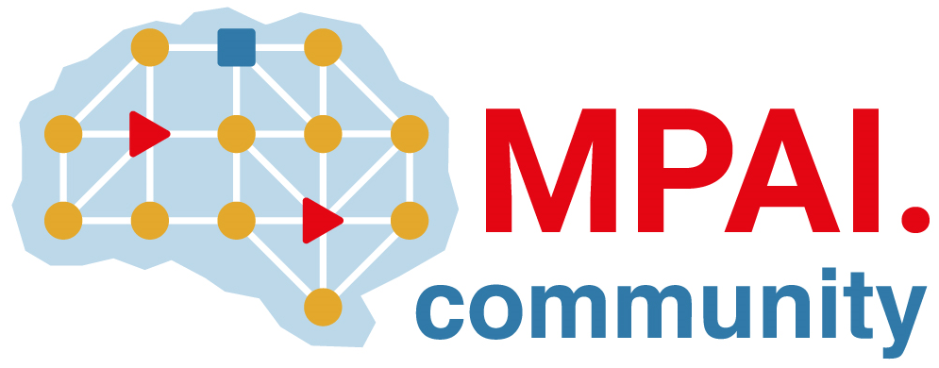 | Moving Picture, Audio and Data Coding by Artificial Intelligence  www.mpai.community

Public document
N2501 | 2025/08/20
Source | 59th MPAI General Assembly (MPAI-59)
Title | MPAI-59 Press Release
Target | MPAI Community

MPAI publishes MPAI Metaverse Model – Technologies V2.1 standard with extended functionalities

Geneva, Switzerland – 20th August 2025. MPAI – Moving Picture, Audio and Data Coding by Artificial Intelligence – the international, non-profit, unaffiliated organisation developing AI-based data coding standards – has concluded its 59th General Assembly (MPAI-59) approving the publication of the MPAI Metaverse Model – Technologies V2.1 with a request for Community Comments.

The earlier 2.0 Version of Technical Specification: MPAI Metaverse Model (MMM) – Technologies (MMM-TEC) already supported digital twinning of real-world environments and their blending with MMM-TEC-specified virtual environments. The new MMM-TEC V2.1 supports “analogue twinning” of virtual- with real-world environments opening attractive industrial metaverse applications. This is achieved by introducing new “Process Actions” (speech acts of an MMM-TEC process sent to another process) and the notion of R-Item (real object) that can be MU-Added (placed at a U-Location, a location in the real world), MU-Moved (moved from a U-Location to another U-Location along a Trajectory), and MU-Animated (animated) in sync with a Persona (the rendering of a Process as an avatar) in the metaverse.

Among the several other innovations included in MMM-TEC V2.1, we mention Change Property, a Process Action whereby a Process changes – if it holds the Rights – the place where and object is located; its properties such as perceptibility, size, mass, gravity, and texture; audio properties such as reflectivity, reverberation, diffusion and absorption; an audio or light source; and the emotional state of an avatar.

MPAI standards are best described as a web of interconnected specifications. The new technologies needed by MMM-TEC are partly specified by Object and Scene Descriptors (MPAI-OSD), Portable Avatar Format (MPAI-PAF), and Data Types, Formats and Attributes (MPAI-TFA). They are now at versions V1.4, V1.5, and V1.4, respectively.

Register to attend the presentations of the many innovations added to
- The MMM-TEC V2.1 standard on 12 September at 15 UTC (link).
- The MPAI-OSD V1.4 and MPAI-PAF V1.5 standards on 12 September at 10 UTC (link).
- The MPAI-TFA standard on Wednesday 17 September at 15 UTC (link)
- The MPAI-GME V2.0 standard on Friday 26 September at 14 UTC (link).

MPAI is continuing the development of its work plan that involves the following activities:
- AI Framework (MPAI-AIF): developing a new MPAI-AIF specification that facilitates the creation of new workflows using available AIMs.
- AI for Health (MPAI-AIH): developing the specification of a system receiving and processing licenses AI Health Data and enabling clients to improve health processing models via federated learning.
- Context-based Audio Enhancement (CAE-DC): developing the Audio Six Degrees of Freedom (CAE-6DF) and Audio Object Scene Rendering (CAE-AOR) specifications.
- Connected Autonomous Vehicle (MPAI-CAV): investigating extensions of the current CAV-TEC specification.
- Compression and Understanding of Industrial Data (MPAI-CUI): developing the Company Performance Prediction V2.0 specification.
- End-to-End Video Coding (MPAI-EEV): exploring the potential of AI-based End-to-End Video coding.
- AI-Enhanced Video Coding (MPAI-EVC): refining the Up-sampling Filter for Video applications (EVC-UFV) standard.
- Governance of the MPAI Ecosystem (MPAI-GME): working on version 2.0 of the Specification.
- Human and Machine Communication (MPAI-HMC): developing reference software and performance assessment.
- Multimodal Conversation (MPAI-MMC): Developing the notion of Perceptive and Agentive AI (PAAI) capable of handling more complex questions.
- MPAI Metaverse Model (MPAI-MMM): extending the capabilities of the MMM-TEC specs to support more applications.
- Neural Network Watermarking (MPAI-NNW): Issuing a Call on Neural Network Traceability Technologies.
- Object and Scene Description (MPAI-OSD): extending the capabilities of the MPAI-OSD V1.3 to support more applications.
- Portable Avatar Format (MPAI-PAF): extending the capabilities of the MPAI-PAF V1.4 to support more applications.
- AI Module Profiles (MPAI-PRF): extending the scope of the current version of AI Module Profiles.
- Server-based Predictive Multiplayer Gaming (MPAI-SPG): exploring new standard opportunities in the domain.
- Data Types, Formats, and Attributes (MPAI-TFA) extending the standard to data types used by MPAI standards (e.g., automotive, health, and metaverse).
- XR Venues (MPAI-XRV): developing the standard for improved development and execution of Live Theatrical Performances.

Legal entities and representatives of academic departments supporting the MPAI mission and able to contribute to the development of standards for the efficient use of data can become MPAI members.

Please visit the MPAI website, contact the MPAI Secretariat for specific information, subscribe to the MPAI Newsletter and follow MPAI on social media: LinkedIn, Twitter, Facebook, Instagram, and YouTube.

