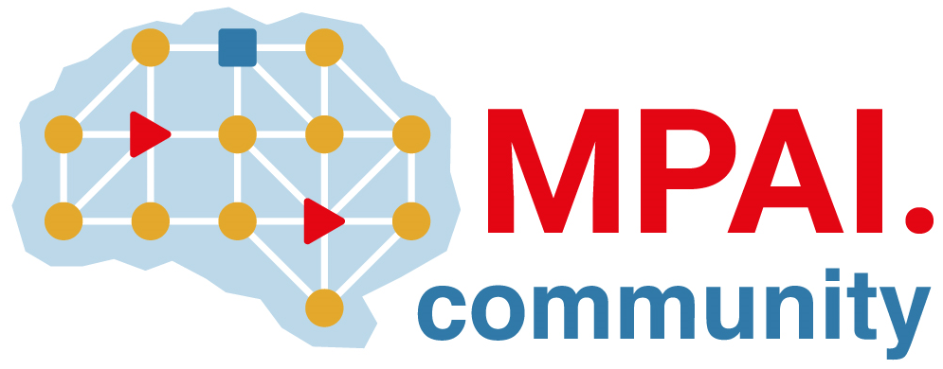 | Moving Picture, Audio and Data Coding by Artificial Intelligence  www.mpai.community

N2503 | 2025/08/20
Source | General Assembly #59 (MPAI-59)
Title | MPAI Timeline
Target | MPAI Community

Table 1 - General Assemblies
2026 |  | 64 | 65 | 66 | 67 | 68 | 69 | 70 | 71 | 72 | 73 | 74 | 75
 | Month | 01 | 02 | 03 | 04 | 05 | 06 | 07 | 08 | 09 | 10 | 11 | 12
 | Day | 21 | 18 | 18 | 15 | 13 | 10 | 08 | 19 | 30 | 28 | 25 | 23
2025 |  | 52 | 53 | 54 | 55 | 56 | 57 | 58 | 59 | 60 | 61 | 62 | 63
 | Month | 01 | 02 | 03 | 04 | 05 | 06 | 07 | 08 | 09 | 10 | 11 | 12
 | Day | 22 | 19 | 19 | 16 | 14 | 11 | 09 | 20 | 30 | 29 | 26 | 17
2024 |  | 40 | 41 | 42 | 43 | 44 | 45 | 46 | 47 | 48 | 49 | 50 | 51
 | Month | 01 | 02 | 03 | 04 | 05 | 06 | 07 | 08 | 09 | 10 | 11 | 12
 | Day | 24 | 21 | 20 | 17 | 15 | 12 | 10 | 21 | 30 | 23 | 20 | 18
2023 |  | 28 | 29 | 30 | 31 | 32 | 33 | 34 | 35 | 36 | 37 | 38 | 39
 | Month | 01 | 02 | 03 | 04 | 05 | 06 | 07 | 08 | 09 | 10 | 11 | 12
 | Day | 25 | 22 | 22 | 19 | 17 | 14 | 12 | 23 | 29 | 25 | 22 | 20
2022 |  | 16 | 17 | 18 | 19 | 20 | 21 | 22 | 23 | 24 | 25 | 26 | 27
 | Month | 01 | 02 | 03 | 04 | 05 | 06 | 07 | 08 | 09 | 10 | 11 | 12
 | Day | 26 | 23 | 23 | 20 | 18 | 22 | 19 | 24 | 30 | 26 | 23 | 21
2021 |  | 4 | 5 | 6 | 7 | 8 | 9 | 10 | 11 | 12 | 13 | 14 | 15
 | Month | 01 | 02 | 03 | 04 | 05 | 06 | 07 | 08 | 09 | 10 | 11 | 12
 | Day | 20 | 17 | 17 | 14 | 12 | 09 | 19 | 25 | 30 | 27 | 24 | 22
2020 | 2020 |  |  |  |  |  |  |  |  | 0 | 1 | 2 | 3
 | Month |  |  |  |  |  |  |  |  | 09 | 10 | 11 | 12
 | Day |  |  |  |  |  |  |  |  | 30 | 21 | 18 | 16

Table 2 – Group meetings until MPAI-60
Group name | 25-29 Aug | 01-05 Sep | 08-12 Sep | 15-19 Sep | 22-26 Sep | 29 Sep-03 Oct | Time (UTC)
AI Framework |  | 1 | 8 | 15 | 22 | 29 | 16
AI-based End-to-End Video Coding | 27 |  | 10 |  | 24 |  | 14
AI-Enhanced Video Coding | 27 | 3 | 10 | 17 | 24 | 1 | 13
Artificial Intelligence for Health |  |  | 8 |  |  |  | 15
Communication | 28 |  | 11 |  | 25 |  | 13:30
Compression & Understanding of Industrial Data | 28 |  |  |  |  |  | 8:30
 |  |  |  | 15 |  |  | 15
Connected Autonomous Vehicle | 28 | 4 | 11 | 18 | 25 | 2 | 15
Context-based Audio enhancement | 26 | 2 | 9 | 16 | 23 |  | 16
Industry and Standards | 29 |  | 12 |  | 26 |  | 16
MPAI Metaverse Model | 29 | 5 | 12 | 19 | 26 | 3 | 15
Multimodal Conversation | 26 | 2 | 9 | 16 | 23 |  | 14
Neural Network Watermarking | 26 | 2 | 9 | 16 | 23 |  | 15
Portable Avatar Format | 29 | 5 | 12 | 19 | 26 | 3 | 10
XR Venues | 26 | 2 | 9 | 16 | 23 |  | 17
General Assembly (MPAI-60) |  |  |  |  |  | 30 | 15

General Assemblies

