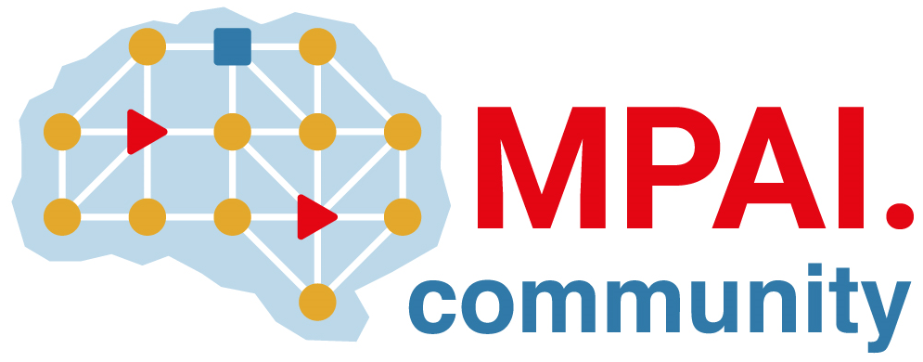 | Moving Picture, Audio and Data Coding by Artificial Intelligence  www.mpai.community

Public document
N2559 | 2025/09/30
Source | 60th MPAI General Assembly (MPAI-60)
Title | MPAI-60 Press Release
Target | MPAI Community

MPAI celebrates five years of pioneering AI standards

Geneva, Switzerland – 30th September 2025. MPAI – Moving Picture, Audio and Data Coding by Artificial Intelligence – the international, non-profit, unaffiliated organisation developing AI-based data coding standards – has celebrated its fifth anniversary at its 60th General Assembly (MPAI-60).

Established 5 years ago on 30 September 2020, MPAI has created the organisation, given itself rigorous procedures of work, developed 15 standards and two technical reports, obtained adoption of eight of its standards without modification by IEEE Standards Association, and is setting sights on next challenges targeting both extensions and new standards.

In line with its mission of AI-based data coding, MPAI standards cover execution of AI applications, audio enhancement, connected autonomous vehicles, finance, human and machine conversation, metaverse, objects and scenes, avatars, and many others.

MPAI-60 has approved final publication of new versions of existing standards:
- Governance of the MPAI Ecosystem V2.0
- MPAI Metaverse Model Technologies V2.1
- Object and Scene Description V1.4
- Portable Avatar Format V1.5
- Data Types, Formats, and Attributes V1.4
and is publishing the following standards for Community Comments
- AI Framework V2.2
- Human and Machine Communication V2.1
- Multimodal Conversation V2.4.

MPAI is continuing the development of its work plan that involves the following activities:
- AI Framework (MPAI-AIF): developing a new MPAI-AIF specification that facilitates the creation of new workflows using available AIMs.
- AI for Health (MPAI-AIH): developing the specification of a system receiving and processing licenses AI Health Data and enabling clients to improve health processing models via federated learning.
- Context-based Audio Enhancement (CAE-DC): developing the Audio Six Degrees of Freedom (CAE-6DF) and Audio Object Scene Rendering (CAE-AOR) specifications.
- Connected Autonomous Vehicle (MPAI-CAV): investigating extensions of the current CAV-TEC specification.
- Compression and Understanding of Industrial Data (MPAI-CUI): developing the Company Performance Prediction V2.0 specification.
- End-to-End Video Coding (MPAI-EEV): exploring the potential of AI-based End-to-End Video coding.
- AI-Enhanced Video Coding (MPAI-EVC): refining the Up-sampling Filter for Video applications (EVC-UFV) standard.
- Governance of the MPAI Ecosystem (MPAI-GME): working on version 2.0 of the Specification.
- Human and Machine Communication (MPAI-HMC): developing reference software and performance assessment.
- Multimodal Conversation (MPAI-MMC): Developing the notion of Perceptive and Agentive AI (PAAI) capable of handling more complex questions.
- MPAI Metaverse Model (MPAI-MMM): extending the capabilities of the MMM-TEC specs to support more applications.
- Neural Network Watermarking (MPAI-NNW): Issuing a Call on Neural Network Traceability Technologies.
- Object and Scene Description (MPAI-OSD): extending the capabilities of the MPAI-OSD V1.3 to support more applications.
- Portable Avatar Format (MPAI-PAF): extending the capabilities of the MPAI-PAF V1.4 to support more applications.
- AI Module Profiles (MPAI-PRF): extending the scope of the current version of AI Module Profiles.
- Server-based Predictive Multiplayer Gaming (MPAI-SPG): exploring new standard opportunities in the domain.
- Data Types, Formats, and Attributes (MPAI-TFA) extending the standard to data types used by MPAI standards (e.g., automotive, health, and metaverse).
- XR Venues (MPAI-XRV): developing the standard for improved development and execution of Live Theatrical Performances.

Legal entities and representatives of academic departments supporting the MPAI mission and able to contribute to the development of standards for the efficient use of data can become MPAI members.

Please visit the MPAI website, contact the MPAI Secretariat for specific information, subscribe to the MPAI Newsletter and follow MPAI on social media: LinkedIn, Twitter, Facebook, Instagram, and YouTube.

