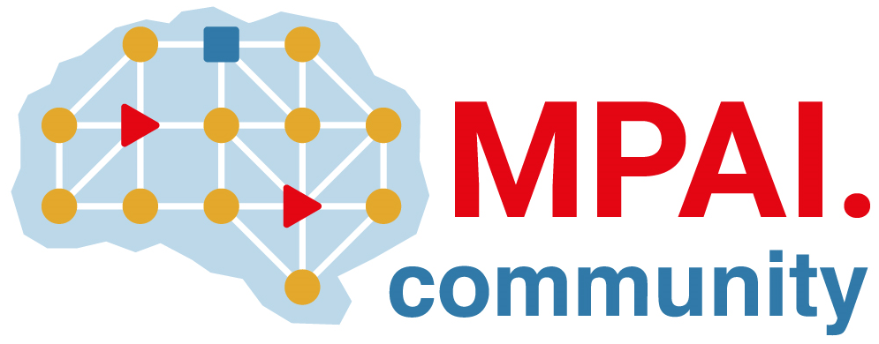 | Moving Picture, Audio and Data Coding by Artificial Intelligence  www.mpai.community

Public document

N2606 | 2025/09/30
Source | Requirements (EEV)
Title | Requirements (EEV) progress report and plans
Target | MPAI-60

The performance of EEV-0.6 software has been updated and some minor gains were achieved.

