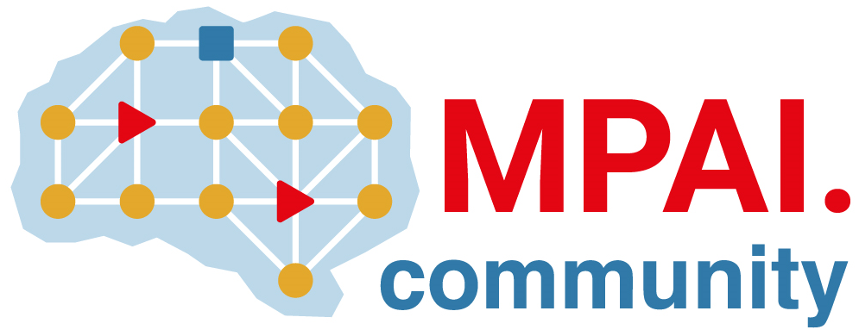 | Moving Picture, Audio and Data Coding by Artificial Intelligence  www.mpai.community

Public document
N2613 | 2025/10/29
Source | 61st MPAI General Assembly (MPAI-61)
Title | MPAI-61 Press Release
Target | MPAI Community

MPAI calls for technologies supporting metaverse-based Agentic AI

Geneva, Switzerland – 29th October 2025. MPAI – Moving Picture, Audio and Data Coding by Artificial Intelligence – the international, non-profit, unaffiliated organisation developing AI-based data coding standards – has concluded its 61st General Assembly (MPAI-61) approving the publication of a Call for Autonomous User Architecture Technologies.

With this Call for Technologies, formally “Pursuing Goals in metaverse (MPAI-PGM) – Autonomous User Architecture (PGM-AUA)”, MPAI is aiming at a standard enabling Autonomous Users to perform activities such as moving around and conversing with other Users. These are processes representing humans in a metaverse conforming with the MPAI Metaverse Model Technologies standard (MMM-TEC). They can either operate with a high degree of autonomy (A-Users) or be directly controlled by humans (H-Users).

PGM-AUA will rely on the friendly MMM-TEC environment and many relevant technologies already available in the 16 approved MPAI standards. However, the ambitious PGM-AUA goal requires many new technologies that the Call is designed to secure.

The text of the call and associated document is available. Responses are due to the MPAI Secretariat by 2025/01/21T23:59.

Register to attend the online presentation of the call and its associated documents on 18 November at 9 UTC and 16 UTC.

MPAI-61 has also approved the new versions of standards previously posted for Community Comments:
- AI Framework V2.2
- Human and Machine Communication V2.1
- Multimodal Conversation V2.4.

MPAI is continuing the development of its work plan that involves the following activities:
- AI Framework (MPAI-AIF): developing a new MPAI-AIF specification that facilitates the creation of new workflows using available AIMs.
- AI for Health (MPAI-AIH): developing the specification of a system receiving and processing licenses AI Health Data and enabling clients to improve health processing models via federated learning.
- Context-based Audio Enhancement (CAE-DC): developing the Audio Six Degrees of Freedom (CAE-6DF) and Audio Object Scene Rendering (CAE-AOR) specifications.
- Connected Autonomous Vehicle (MPAI-CAV): investigating extensions of the current CAV-TEC specification.
- Compression and Understanding of Industrial Data (MPAI-CUI): developing the Company Performance Prediction V2.0 specification.
- End-to-End Video Coding (MPAI-EEV): exploring the potential of AI-based End-to-End Video coding.
- AI-Enhanced Video Coding (MPAI-EVC): finalising the Up-sampling Filter for Video applications (EVC-UFV) standard.
- Governance of the MPAI Ecosystem (MPAI-GME): operating the MPAI Ecosystem per the MPAI-GME Specification.
- Human and Machine Communication (MPAI-HMC): developing reference software and performance assessment.
- Multimodal Conversation (MPAI-MMC): discussing the conversational part of the PGM-AUA Call for Technologies.
- MPAI Metaverse Model (MPAI-MMM): developing support for security in the MMM-TEC specs.
- Neural Network Watermarking (MPAI-NNW): Reviewing the responses to the Call on Neural Network Traceability Technologies.
- Object and Scene Description (MPAI-OSD): discussing the spatial part of the PGM-AUA Call for Technologies.
- Portable Avatar Format (MPAI-PAF): discussing the rendering part of the PGM-AUA Call for Technologies.
- AI Module Profiles (MPAI-PRF): extending the scope of the current version of AI Module Profiles.
- Server-based Predictive Multiplayer Gaming (MPAI-SPG): exploring new standard opportunities in the domain.
- Data Types, Formats, and Attributes (MPAI-TFA) extending the standard to data types used by MPAI standards (e.g., automotive, health, and metaverse).
- XR Venues (MPAI-XRV): developing the standard for improved development and execution of Live Theatrical Performances.

Legal entities and representatives of academic departments supporting the MPAI mission and able to contribute to the development of standards for the efficient use of data can become MPAI members.

Please visit the MPAI website, contact the MPAI Secretariat for specific information, subscribe to the MPAI Newsletter and follow MPAI on social media: LinkedIn, Twitter, Facebook, Instagram, and YouTube.

