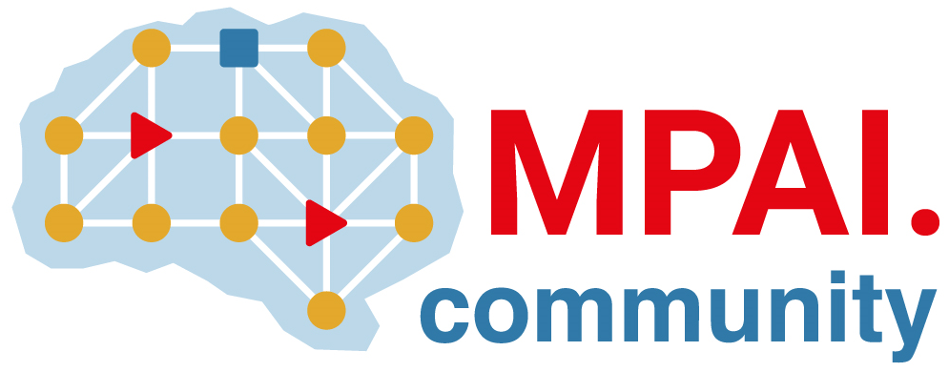 | Moving Picture, Audio and Data Coding by Artificial Intelligence  www.mpai.community

Public document
N2659 | 2025/10/29
Source | Requirements (EEV)
Title | Requirements (EEV) progress report and plans
Target | MPAI-61

Requirements (EEV) has made significant progress in learned video coding and there are five versions of reference software. The EEV group has made a practical step in preparing the draft to standardize a neural video codec.

The EEV-0.6 reference model is still under construction and advancing towards higher coding performances. The latest model has over 5% better than the H.266/VVC reference software VTM-23.0 with Random Access configuration.

