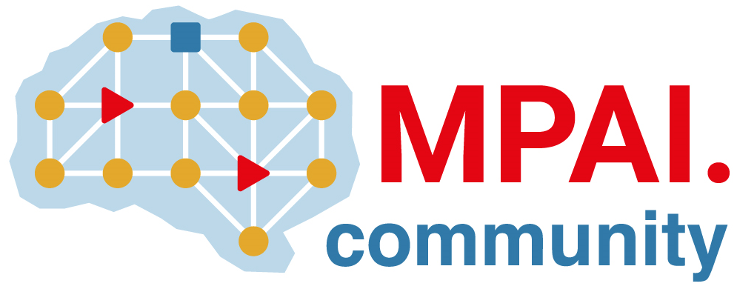 | Moving Picture, Audio and Data Coding by Artificial Intelligence  www.mpai.community

Public document

N2759 | 2025/12/17
Source | Requirements (EEV)
Title | Requirements (EEV) progress report and plans
Target | MPAI-63

Requirements (EEV) has made significant progress in learned video coding and there are five versions of reference software. The EEV group has made a practical step in preparing the draft to standardize a neural video codec.

The EEV group has constructed a very encouraging model named EEV-0.6. The latest model has better performances than the H.266/VVC reference software VTM-23.0 with Random Access configuration.

