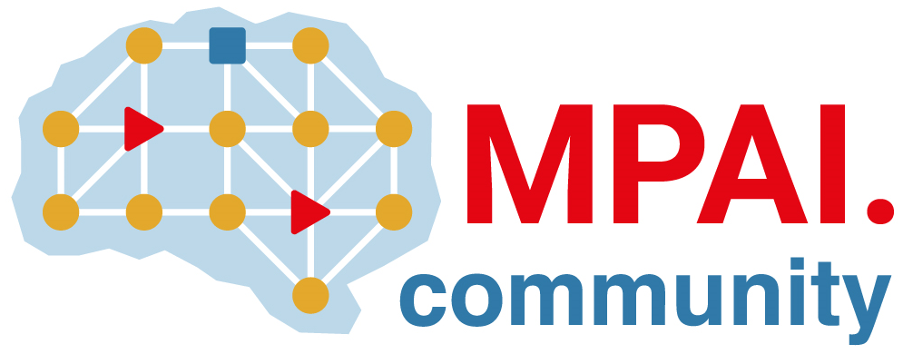 | Moving Picture, Audio and Data Coding by Artificial Intelligence  www.mpai.community

Public document
N2872 | 2026/03/18
Source | 66th MPAI General Assembly (MPAI-66)
Title | MPAI-66 Press Release
Target | MPAI Community

MPAI publishes the “MPAI as a Service” Call for Technologies
and the MPAI Metaverse Model standard V2.2 for Community Comments

Geneva, Switzerland – 18th March 2026. MPAI – Moving Picture, Audio and Data Coding by Artificial Intelligence – the international, non-profit, unaffiliated organisation developing AI-based data coding standards – has concluded its 66th General Assembly (MPAI-66) publishing a Call for Technologies regarding the planned “MPAI as a Service” (MaaS) standard and MPAI Metaverse Model – Technologie (MMM-TEC) V2.2.

MPAI as a Service is the code name of the target service that would make it possible for a client application to access sophisticated AI processing services by launching an AI Workflow downloaded from the MPAI Store by a remote MPAI AI Framework (MPAI-AIF) processing environment. The Call requests technologies that leverage the MPAI-AIF Application Programming Interface for the reduction of the MPAI Store traffic when downloading AI Workflow components, such as bulky neural network models, from the required certified distributed repository servers.

The next steps are:
- Register to attend the 30 March online presentations of the Call at 8:00 and 15:00 UTC.
- Submit a response to the Call to the MPAI Secretariat by 13 April at 16 UTC.
- Start the MPAI as a Service standard development on 15 April (MPAI-67).

MPAI-66 has also reached another important milestone with the publication of Version 2.2 of the now well-established MPAI Metaverse Model – Technologies (MMM-TEC) standard. This new version adds a major set of technologies enabling the deployment of a sophisticated virtual economy and a new open-source implementation of MMM-TEC based on OpenSimulator. The standard is published with a Request for Community Comments until 11 May. Learn about the opportunities offered by the new MMM-TEC version by registering to attend the public online presentation on 9 April at 15:00 UTC.

MPAI is continuing the development of its work plan that involves the following activities:
- AI Framework (MPAI-AIF): developing a Call for Technologies to extend the MPAI-AIF standard to enable a Remote Client Application to access a remote MPAI-AIF Controller, download and execute an AI Workflow, and access the result of the AIW processing.
- AI for Health (AIH-HSP): reviewing the specification of a system receiving and processing licenses AI Health Data and enabling clients to improve health processing models via federated learning.
- Context-based Audio Enhancement (CAE-USC): developing the Audio Six Degrees of Freedom (CAE-6DF) and the Audio Object Rendering (CAE-AOR) standards.
- Connected Autonomous Vehicle (CAV-TEC): developing a new version of the flagship specification CAV-TEC with security support.
- Compression and Understanding of Industrial Data (CUI-CPP): developing a reference software implementation of CUI-CPP V2.0.
- End-to-End Video Coding (MPAI-EEV): exploring the potential of AI-based End-to-End Video coding in compressing video sequences.
- AI-Enhanced Video Coding (MPAI-EVC): exploring new standards that benefit from the use of Super Resolution filters.
- Governance of the MPAI Ecosystem (MPAI-GME): operating the MPAI Ecosystem per the MPAI-GME Specification.
- Human and Machine Communication (MPAI-HMC): exploring the use of AI in human-to-machine and machine-to-machine communication.
- Multimodal Conversation (MPAI-MMC): developing specifications of new data types especially in the context of the PGM-AUA standard.
- MPAI Metaverse Model (MMM-TEC): developing V2.2 of MMM-TEC with capabilities enabling virtual metaverse economies.
- Neural Network Watermarking (NNW-TEC): Refining the new Neural Network Watermarking (MPAI-NNW) – Technologies (NNW-TEC) standard published for Community Comments.
- Object and Scene Description (MPAI-OSD): developing specifications of new data types especially in the context of the PGM-AUA standard.
- Portable Avatar Format (MPAI-PAF): discussing the impact of MPAI standards planned or under development on MPAI-PAF V1.5.
- AI Module Profiles (MPAI-PRF): extending the scope of the current version of AI Module Profiles.
- Server-based Predictive Multiplayer Gaming (MPAI-SPG): exploring new standard opportunities in the domain.
- Data Types, Formats, and Attributes (MPAI-TFA) extending the standard to data types used by MPAI standards that are planned or under development.
- XR Venues (XRV-LTP): developing the standard for improved execution of Live Theatrical Performances using AI.

Legal entities and representatives of academic departments supporting the MPAI mission and able to contribute to the development of standards for the efficient use of data can become MPAI members. New members joining before 31st December 2025 have their membership extended until 31st December 2026.

Please visit the MPAI website, contact the MPAI Secretariat for specific information, subscribe to the MPAI Newsletter and follow MPAI on social media: LinkedIn, Twitter, Facebook, Instagram, and YouTube.

