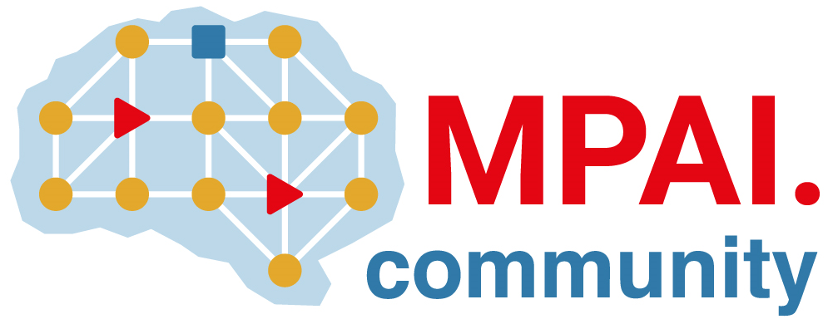 | Moving Picture, Audio and Data Coding by Artificial Intelligence  www.mpai.community

Public document
N2973 | 2026/05/13
Source | 67th MPAI General Assembly (MPAI-68)
Title | MPAI-68 Press Release
Target | MPAI Community

MPAI publishes “AI for Health – Health Secure Platform” and
“Neural Network Watermarking - Technologies”

Geneva, Switzerland – 15th April 2026. MPAI – Moving Picture, Audio and Data Coding by Artificial Intelligence – the international, non-profit, unaffiliated organisation developing AI-based data coding standards – has concluded its 68th General Assembly (MPAI-68) publishing AI for Health (MPAI-AIH) – Health Secure Platform (AIH-HSP) and Neural Network Watermarking (MPAI-NNW) – Technologies (TEC) as MPAI Standards.

AIH-HSP enables End Users to use their Front Ends to capture, process, license, and upload health data to the system Back End where user-generated licences are converted into smart contracts, and their health data are processed per the smart contracts. From time to time the neural networks in the Front Ends are collected, updated using Federated Larning Technologies, and redistributed to End Users. .

NNW-TEC utilises the previously approved Neural Network Watermarking – Technologies (NNW-NNT) standard to assess different watermarking technologies on a shared testbed.

MPAI-68 has also approved Version V1.1 of Connected Autonomous Vehicle (MPAI-CAV) – Technologies (CAV-TEC) as a draft standard published with a request for Community Comments until 2026/07/08. The focus is on ensuring security of the processing subsystem of the Connected Autonomous Vehicle.

MPAI is continuing the development of its work plan that involves the following activities:
- AI Framework (MPAI-AIF): developing a Call for Technologies to extend the MPAI-AIF standard to enable a Remote Client Application to access a remote MPAI-AIF Controller, download and execute an AI Workflow, and access the result of the AIW processing.
- AI for Health (AIH-HSP): reviewing areas relevant for AI for Health.
- Context-based Audio Enhancement (CAE-USC): developing the Audio Six Degrees of Freedom (CAE-6DF) and the Audio Object Rendering (CAE-AOR) standards.
- Connected Autonomous Vehicle (CAV-TEC): developing a new version of the flagship specification CAV-TEC with security support.
- Compression and Understanding of Industrial Data (CUI-CPP): developing a reference software implementation of CUI-CPP V2.0.
- End-to-End Video Coding (MPAI-EEV): exploring the potential of AI-based End-to-End Video coding in compressing video sequences.
- AI-Enhanced Video Coding (MPAI-EVC): exploring new standards that benefit from the use of Super Resolution filters.
- Governance of the MPAI Ecosystem (MPAI-GME): operating the MPAI Ecosystem per the MPAI-GME Specification.
- Human and Machine Communication (MPAI-HMC): exploring the use of AI in human-to-machine and machine-to-machine communication.
- Multimodal Conversation (MPAI-MMC): developing specifications of new data types especially in the context of the PGM-AUA standard.
- MPAI Metaverse Model (MMM-TEC): developing V2.2 of MMM-TEC with capabilities enabling virtual metaverse economies.
- Neural Network Watermarking (NNW-TEC): Reviewing new Neural Network Watermarking areas.
- Object and Scene Description (MPAI-OSD): developing specifications of new data types especially in the context of the PGM-AUA standard.
- Portable Avatar Format (MPAI-PAF): discussing the impact of MPAI standards planned or under development on MPAI-PAF V1.5.
- AI Module Profiles (MPAI-PRF): extending the scope of the current version of AI Module Profiles.
- Server-based Predictive Multiplayer Gaming (MPAI-SPG): exploring new standard opportunities in the domain.
- Data Types, Formats, and Attributes (MPAI-TFA) extending the standard to data types used by MPAI standards that are planned or under development.
- XR Venues (XRV-LTP): developing the standard for improved execution of Live Theatrical Performances using AI.

Legal entities and representatives of academic departments supporting the MPAI mission and able to contribute to the development of standards for the efficient use of data can become MPAI members.

Please visit the MPAI website, contact the MPAI Secretariat for specific information, subscribe to the MPAI Newsletter and follow MPAI on social media: LinkedIn, Twitter, Facebook, Instagram, and YouTube.

