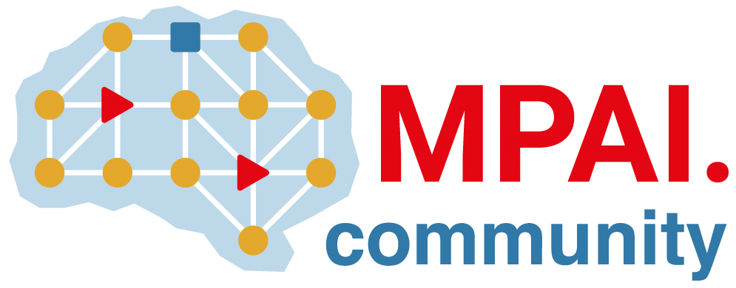 | Moving Picture, Audio and Data Coding by Artificial Intelligence  www.mpai.community

Public document

N2975 | 2026/05/13
Source | General Assembly #68 (MPAI-68)
Title | MPAI Timeline
Target | MPAI Community

Table 1 - General Assemblies
2026 |  | 64 | 65 | 66 | 67 | 68 | 69 | 70 | 71 | 72 | 73 | 74 | 75
 | Month | 01 | 02 | 03 | 04 | 05 | 06 | 07 | 08 | 09 | 10 | 11 | 12
 | Day | 21 | 18 | 18 | 15 | 13 | 10 | 08 | 19 | 30 | 28 | 25 | 23
2025 |  | 52 | 53 | 54 | 55 | 56 | 57 | 58 | 59 | 60 | 61 | 62 | 63
 | Month | 01 | 02 | 03 | 04 | 05 | 06 | 07 | 08 | 09 | 10 | 11 | 12
 | Day | 22 | 19 | 19 | 16 | 14 | 11 | 09 | 20 | 30 | 29 | 26 | 17
2024 |  | 40 | 41 | 42 | 43 | 44 | 45 | 46 | 47 | 48 | 49 | 50 | 51
 | Month | 01 | 02 | 03 | 04 | 05 | 06 | 07 | 08 | 09 | 10 | 11 | 12
 | Day | 24 | 21 | 20 | 17 | 15 | 12 | 10 | 21 | 30 | 23 | 20 | 18
2023 |  | 28 | 29 | 30 | 31 | 32 | 33 | 34 | 35 | 36 | 37 | 38 | 39
 | Month | 01 | 02 | 03 | 04 | 05 | 06 | 07 | 08 | 09 | 10 | 11 | 12
 | Day | 25 | 22 | 22 | 19 | 17 | 14 | 12 | 23 | 29 | 25 | 22 | 20
2022 |  | 16 | 17 | 18 | 19 | 20 | 21 | 22 | 23 | 24 | 25 | 26 | 27
 | Month | 01 | 02 | 03 | 04 | 05 | 06 | 07 | 08 | 09 | 10 | 11 | 12
 | Day | 26 | 23 | 23 | 20 | 18 | 22 | 19 | 24 | 30 | 26 | 23 | 21
2021 |  | 4 | 5 | 6 | 7 | 8 | 9 | 10 | 11 | 12 | 13 | 14 | 15
 | Month | 01 | 02 | 03 | 04 | 05 | 06 | 07 | 08 | 09 | 10 | 11 | 12
 | Day | 20 | 17 | 17 | 14 | 12 | 09 | 19 | 25 | 30 | 27 | 24 | 22
2020 | 2020 |  |  |  |  |  |  |  |  | 0 | 1 | 2 | 3
 | Month |  |  |  |  |  |  |  |  | 09 | 10 | 11 | 12
 | Day |  |  |  |  |  |  |  |  | 30 | 21 | 18 | 16

Table 2 – Group meetings until MPAI-69

Group name | 18-22 May | 25-29 May | 01-05 June | 08-12 June | Time (UTC)
AI Framework | 18 | 25 | 1 | 8 | 15
AI-based End-to-End Video Coding |  | 27 |  |  | 14
AI-Enhanced Video Coding |  |  | 3 |  | 13
Artificial Intelligence for Health | 21 |  | 1 | 8 | 14
Communication | 21 |  | 4 |  | 13
Compression & Underst. of Industrial Data |  |  | 1 |  | 8:30
Compression & Underst. of Industrial Data | 19 |  |  | 8 | 9
Connected Autonomous Vehicle |  | 28 | 4 | 11 | 14
Context-based Audio enhancement | 19 | 26 | 2 | 9 | 16
Industry and Standards | 22 |  | 5 |  | 16
MPAI Metaverse Model | 21 | 28 | 4 | 11 | 15
Multimodal Conversation | 19 | 26 | 2 | 9 | 14
Neural Network Watermarking | 19 | 26 | 2 | 9 | 15
Portable Avatar Format | 22 | 29 | 5 | 12 | 8
XR Venues | 19 | 26 | 2 | 9 | 17
General Assembly (MPAI-69) |  |  |  | 10 | 15

General Assemblies

