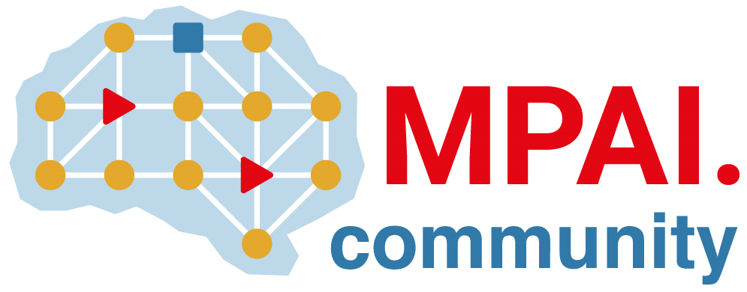 | Moving Picture, Audio and Data Coding by Artificial Intelligence  www.mpai.community

Public document
N2992 | 2026/05/13
Source | CUI-DC
Title | Functional Requirements: AI Passport (MPAI-AIP)
Target | MPAI Community

Introduction
State of the art about AI governance
- ISO/IEC 4200x AI Governance provide procedural rules but: lack specifications for practical operation, leaving this to the initiative of individual companies/entities.
- Approved Regional regulations (e.g., AI Act) provide legally binding normative acts adopted through a formal legislative or administrative process high-level normative clauses but lacking practical applicable procedures.

We need a specification describing the parameters (“AI passport”) that characterise an AI vis-à-vis its users and the operational context in which the AI is applied. This is an initial list of such parameters

Definitions:
- Hash: a function characterised by the properties of fixed length, bit sensitivity, and anti-collusion or uniqueness that applied to a file containing a trained AI with its parameters.
- Ground Model: a pre-trained model or a model architecture that undergoes the target training.

Functional Requirements

General requirements
Table 1 includes two columns, the first provides the entries of the AI Passport and the second the functional requirements.

Table 1 - Rable 1 - Functional Requirements for AI Passport
- AI Passport ID | - ID of an AI Passport associated to a specific AI Instance  - ID shall be provided by  - an authorised agency  - the AI developer if an agency.  - An ID identifies to an AI model with bit-wise reference to the entries of the AI Passport. below.  - An AI may have more than one ID.
- Agency ID | Id of the entity that issued the Passport (agency or developer if an agency).
- Hash | Hash used to validate that the AI instance is what it says to be. Note that if the AI changes, the hash is different.
- Function | Natural Language Text describing what the AI is intended to do.
- Certification | - The legislations and regulations under which the operation of the AI was certified  - Taxonomy of relevant legislations and regulations needed
- Inputs | The input interfaces of the AI
- Protocol(s) | - Protocols used to input data  - Taxonomy of relevant protocols needed
- Data Semantics | - The semantics of the input data (qualifier, taxonomy)  - MPAI has a data type Taxonomy  - Other taxonomies can be referenced
- Data Governance | - The legislations and regulations under which the input data was produced  - Taxonomy needed (different than the one above)
- Outputs | The output interfaces of the AI
- Protocol(s) | - Protocols used to input data  Taxonomy of relevant protocols needed
- Data Semantics | - The semantics of the input data (qualifier, taxonomy)  - MPAI has a data type Taxonomy  - Other taxonomies can be referenced
- Origin | Information on AI creation
- Ground Model | - Identified according to a standard identification system for AI Models (to be developed).  - Agencies identifying the models are identified.
- Training data | - The name of the data set (as set by the data set developer)  - A reference (e.g., DOI, URL, hash),  - DAO (Decentralized Autonomous Organisation)
- General KPIs | - List of application-independent KPIs for the AI, e.g., Precision, AUC.  - Each KPI has  - KPI name  - Reference specification defining it  - List of KPIs to be developed.
- Application KPIs | - List of application-independent KPIs for the AI  - Each KPI has  - KPI name,  - Target application  - Reference specification defining KPI.  - Guidelines for app-dependent KPIs may be developed.
  - Ethical
- Accountability | - List of methods that take accountability issues into account.  - Each method has  - Short name,  - Reference (e.g., DOI, URL, official doc),  - How it is adopted by the AI (by design, bias, and ex-post KPI).
- Environmental | Do.
- Social (Dual use) | Do.
- Technology
- Hardware Architecture | Shall reference a Taxonomy (Vendor, Hardware type)
- Run-time environment | Shall reference a Taxonomy (Developer, Name, Version, OS)

AI-Passport binding requirements
How to bind the Passport with the AI
- Watermark the AI with a payload that contains the Passport ID.
- Create a macro-object that includes the AI and the Passport.

