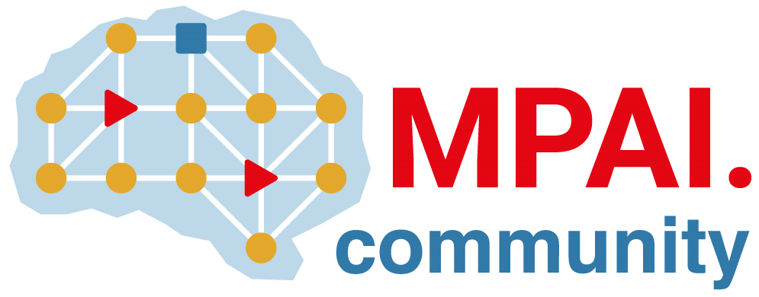 | Moving Picture, Audio and Data Coding  by Artificial Intelligence  www.mpai.community

Public document
N2993 | 2026/05/13
Source | Requirements (EVC)
Title | MPAI-EVC progress report and plans
Target | MPAI Community

EVC has agreed to consider the development of a standard for joint optimisation of down-sampling and up-sampling filter.
A first meeting was held with participation of non0-MPAI members. One issue is the identification of a “virtual coded” to be inserted in the training process to simulate the effects of a codec.
.

