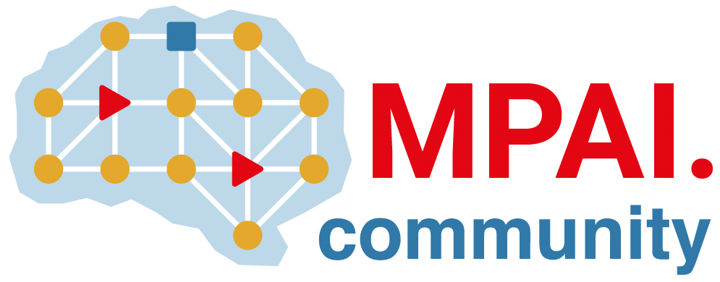 | Moving Picture, Audio and Data Coding by Artificial Intelligence  www.mpai.community

Public document
N3016 | 2026/05/13
Source | Requirements (EEV)
Title | Requirements (EEV) progress report and plans
Target | MPAI Community

Requirements (EEV) has made significant progress in learned video coding and there are five versions of reference software. The EEV group has made a practical step in preparing the draft to standardize a neural video codec.

The latest reference model of EEV, EEV-0.6, has been finalized and the press release is also been delivered. In recent activities, EEV group is preparing for the upcoming CVPR conference to showcase this model and have summarized some related studies for future redirections.

