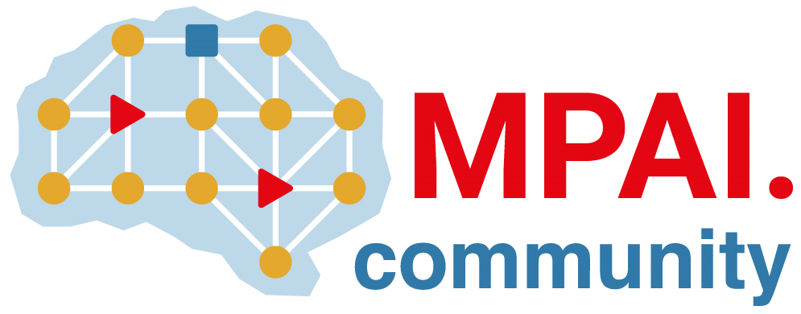 | Moving Picture, Audio and Data Coding by Artificial Intelligence  www.mpai.community

Public document
N3023 | 2026/06/10
Source | 69th MPAI General Assembly (MPAI-69)
Title | MPAI-69 Press Release
Target | MPAI Community

MPAI publishes Version 1.1 of “Connected Autonomous Vehicle – Technologies (CAV-TEC)”

Geneva, Switzerland – 10th June 2026. MPAI – Moving Picture, Audio and Data Coding by Artificial Intelligence – the international, non-profit, unaffiliated organisation developing AI-based data coding standards – has concluded its 69th General Assembly (MPAI-69) publishing Connected Autonomous Vehicle (MPAI-CAV) – Technologies (CAV-TEC) as MPAI Standard.

CAV-TEC V1.1 specifies the human-machine interaction, sensing, communication, reasoning, and control parts of a vehicle capable of driving autonomously with the support of information exchanged with other similar vehicles in range. It is based on the well-established AI Framework standard (MPAI-AIF) providing a secure environment suitable for the execution of independent processes called AI Modules, performing functions and exchanging data as specified by the CAV-TEC V1.1 Reference Model. The AI Framework enables interworking of independently developed AI-Modules, thus promoting the development of an open market for autonomous vehicle components.

CAV-TEC V1.1 will be presented online on the 1st of July 2026 at 16:00 UTC. Register here to participate

MPAI is continuing the development of its work plan that involves the following activities:
- AI Framework (MPAI-AIF): developing a Call for Technologies to extend the MPAI-AIF standard to enable a Remote Client Application to access a remote MPAI-AIF Controller, download and execute an AI Workflow, and access the result of the AIW processing.
- AI for Health (AIH-HSP): reviewing areas relevant for AI for Health and preparing for the development of Reference Software.
- Context-based Audio Enhancement (CAE-USC): developing the Audio Six Degrees of Freedom (CAE-6DF) and the Audio Object Rendering (CAE-AOR) standards.
- Connected Autonomous Vehicle (CAV-TEC): preparing for the development of Reference Software.
- Compression and Understanding of Industrial Data (CUI-CPP): developing a reference software implementation of CUI-CPP V2.0.
- End-to-End Video Coding (MPAI-EEV): exploring the potential of AI-based End-to-End Video coding in compressing video sequences.
- AI-Enhanced Video Coding (MPAI-EVC): exploring the possibility of a new standard for optimised down- and up-sampling filters..
- Governance of the MPAI Ecosystem (MPAI-GME): operating the MPAI Ecosystem per the MPAI-GME Specification.
- Human and Machine Communication (MPAI-HMC): exploring the use of AI in human-to-machine and machine-to-machine communication.
- Multimodal Conversation (MPAI-MMC): developing specifications of new data types especially in the context of the PGM-AUA standard.
- MPAI Metaverse Model (MMM-TEC): developing V2.2 of MMM-TEC with capabilities enabling virtual metaverse economies.
- Neural Network Watermarking (NNW-TEC): Reviewing new Neural Network Watermarking areas.
- Object and Scene Description (MPAI-OSD): developing specifications of new data types especially in the context of the PGM-AUA standard.
- Portable Avatar Format (MPAI-PAF): discussing the impact of MPAI standards planned or under development on MPAI-PAF V1.5.
- AI Module Profiles (MPAI-PRF): extending the scope of the current version of AI Module Profiles.
- Server-based Predictive Multiplayer Gaming (MPAI-SPG): exploring new standard opportunities in the domain.
- Data Types, Formats, and Attributes (MPAI-TFA) extending the standard to data types used by planned or under development MPAI standards.
- XR Venues (XRV-LTP): developing the standard for improved execution of Live Theatrical Performances using AI.

Legal entities and representatives of academic departments supporting the MPAI mission and able to contribute to the development of standards for the efficient use of data can become MPAI members.

Please visit the MPAI website, contact the MPAI Secretariat for specific information, subscribe to the MPAI Newsletter and follow MPAI on social media: LinkedIn, Twitter, Facebook, Instagram, and YouTube.

