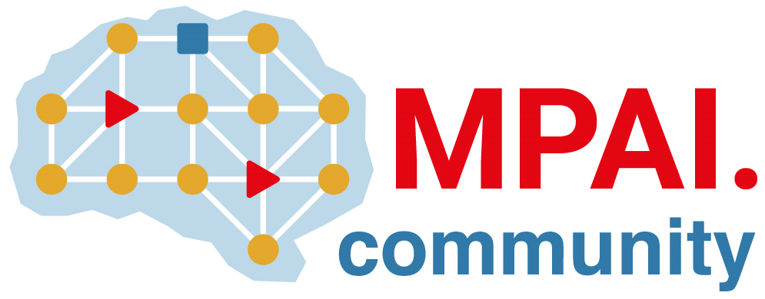 | Moving Picture, Audio and Data Coding by Artificial Intelligence  www.mpai.community

Public document
N3040 | 2026/06/10
Source | Requirements (EEV)
Title | Requirements (EEV) progress report and plans
Target | MPAI Community

The latest reference model of EEV, EEV-0.6, has been finalized and the press release is also been delivered.

