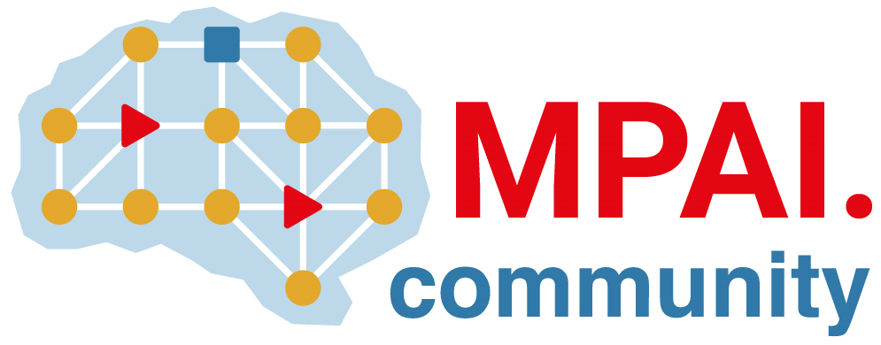 | Moving Picture, Audio and Data Coding  by Artificial Intelligence  www.mpai.community

Public document
N3041 | 2026/06/10
Source | Requirements (EVC)
Title | MPAI-EVC progress report and plans
Target | MPAI Community

EVC has agreed to consider the development of a standard for joint optimisation of down-sampling and up-sampling filter.
At a further meeting is was agreed that the first experiment will be to assess the gain of a chain of one down- and one up-sampling filter.
.

