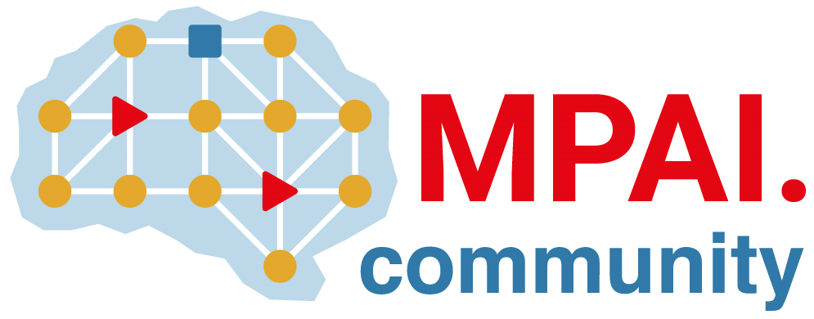 | Moving Picture, Audio and Data Coding by Artificial Intelligence  www.mpai.community

Public document
N3073 | 2026/07/08
Source | 70th MPAI General Assembly (MPAI-70)
Title | MPAI-70 Press Release
Target | MPAI Community

MPAI publishes the Draft “MPAI as a Service” V1.0 standard and “MPAI Metaverse Model – Technologies” V2.2 as an MPAI standard

Geneva, Switzerland – 8th July 2026. MPAI – Moving Picture, Audio and Data Coding by Artificial Intelligence – the international, non-profit, unaffiliated organisation developing AI-based data coding standards – has concluded its 70th General Assembly (MPAI-70) publishing:
- AI Framework (MPAI-AIF) V3.0 V1.0 with a Request for Community Comments
- Context-based Audio Enhancement – Audio Object Rendering (CAE-AOR) V1.0 with a Request for Community Comments
- MPAI as a Service (MPAI-MAS) V1.0 with a Request for Community Comments
- MPAI Metaverse Model – Technologies (MMM-TEC) V2.2 as an MPAI standard.

AI Framework (MPAI-AIF) is a foundational MPAI standard that enables the execution of AI processes in a standard environment. Among other updates, MPAI-AIF V3.0 includes APIs enabling a Controller in an MPAI as a Service context to verify that an AI Module that has not been downloaded from the MPAI Store, is the one the Controller intended.

Audio Object Rendering (CAE-AOR) is one of the Context-based Audio Enhancement standards. It enables a user to modify a wide range of properties of Audio Objects in an audio scene and render the resulting Audio Object to experience the immersive space from different perspectives through headphones or loudspeakers.

MPAI as a Service (MPAI-MAS) enables a client application to request execution of an AI Module by a Controller running on a remote MPAI AI Framework instance. MPAI-MAS enables cloud service providers to offer to their customers online execution services of AI applications.

MPAI Metaverse Model – Technologies (MMM-TEC) V2.2 is one of the MPAI flagship standards that integrates a variety of technologies developed by various MPAI organisational units. Leveraging its basic security technologies – such as unique Identifiers, Rights, and Rules – and the new technologies added on this occasion, MMM-TEC V2.2 enables the development of versatile market economies.

MPAI-70 also announced that on 15 July at 14 UTC a Seminar on “A future for Video Coding – The MPAI End-to-End Video Coding (EEV) Project” will be held online. The goal is two-fold: to review what has been learned from the last years of investigation that led the EEV-0.6 reference model to outperform the VVC standard and to explore promising avenues of development for the coming EEV-0.7 reference model. Register here to attend.

MPAI is continuing the development of its work plan that involves the following activities:
- AI Framework (MPAI-AIF): developing a Call for Technologies to extend the MPAI-AIF standard to enable a Remote Client Application to access a remote MPAI-AIF Controller, download and execute an AI Workflow, and access the result of the AIW processing.
- AI for Health (AIH-HSP): reviewing areas relevant for AI for Health and preparing for the development of Reference Software.
- Context-based Audio Enhancement (CAE-USC): developing the Audio Six Degrees of Freedom (CAE-6DF) and the Audio Object Rendering (CAE-AOR) standards.
- Connected Autonomous Vehicle (CAV-TEC): preparing for the development of Reference Software.
- Compression and Understanding of Industrial Data (CUI-CPP): developing a reference software implementation of CUI-CPP V2.0.
- End-to-End Video Coding (MPAI-EEV): exploring the potential of AI-based End-to-End Video coding in compressing video sequences.
- AI-Enhanced Video Coding (MPAI-EVC): exploring the possibility of a new standard for optimised down- and up-sampling filters..
- Governance of the MPAI Ecosystem (MPAI-GME): operating the MPAI Ecosystem per the MPAI-GME Specification.
- Human and Machine Communication (MPAI-HMC): exploring the use of AI in human-to-machine and machine-to-machine communication.
- Multimodal Conversation (MPAI-MMC): developing specifications of new data types especially in the context of the PGM-AUA standard.
- MPAI Metaverse Model (MMM-TEC): developing V2.2 of MMM-TEC with capabilities enabling virtual metaverse economies.
- Neural Network Watermarking (NNW-TEC): Reviewing new Neural Network Watermarking areas.
- Object and Scene Description (MPAI-OSD): developing specifications of new data types especially in the context of the PGM-AUA standard.
- Portable Avatar Format (MPAI-PAF): discussing the impact of MPAI standards planned or under development on MPAI-PAF V1.5.
- AI Module Profiles (MPAI-PRF): extending the scope of the current version of AI Module Profiles.
- Server-based Predictive Multiplayer Gaming (MPAI-SPG): exploring new standard opportunities in the domain.
- Data Types, Formats, and Attributes (MPAI-TFA) extending the standard to data types used by planned or under development MPAI standards.
- XR Venues (XRV-LTP): developing the standard for improved execution of Live Theatrical Performances using AI.

Legal entities and representatives of academic departments supporting the MPAI mission and able to contribute to the development of standards for the efficient use of data can become MPAI members.

Please visit the MPAI website, contact the MPAI Secretariat for specific information, subscribe to the MPAI Newsletter and follow MPAI on social media: LinkedIn, Twitter, Facebook, Instagram, and YouTube.

