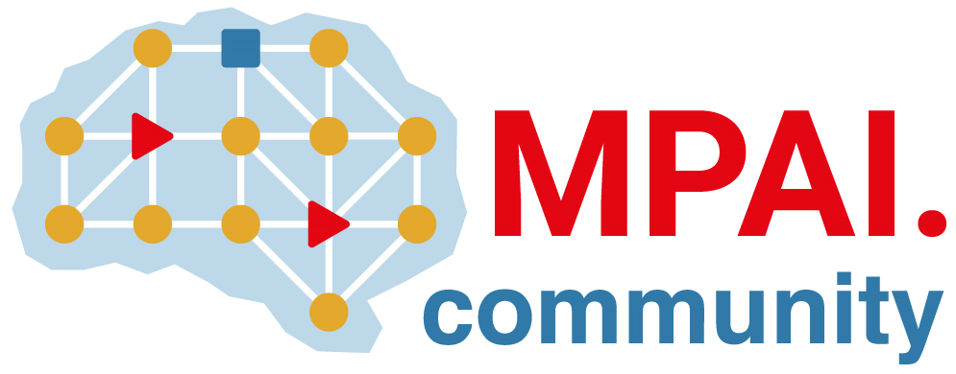 | Moving Picture, Audio and Data Coding by Artificial Intelligence  www.mpai.community

Public document
N3089 | 2026/07/08
Source | Requirements (EEV)
Title | Requirements (EEV) progress report and plans
Target | MPAI Community

Requirements (EEV) is planning a move to EEV-0.7

