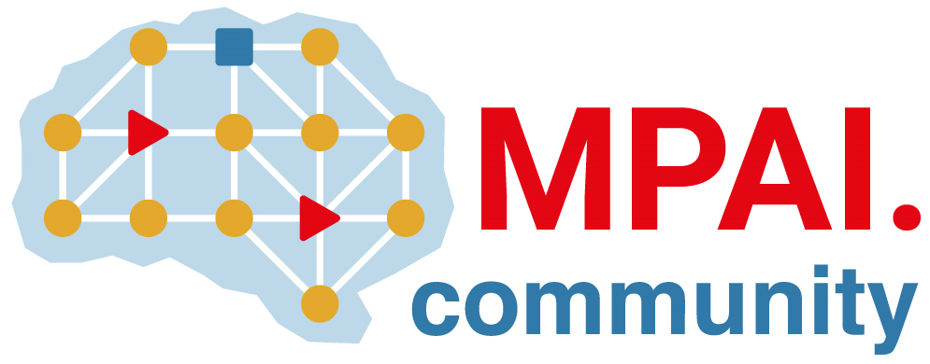 | Moving Picture, Audio and Data Coding  by Artificial Intelligence  www.mpai.community

N3132 | 2026/08/19
Source | Requirements (AIP)
Title | Framework Licence AI Passport (MPAI-AIP) V1.0
Target | MPAI Community
- Coverage
This Framework Licence applies to Technical Specification: AI Passport (MPAI-AIP) V1.0 (in the following “Standard”) as adopted by Moving Picture, Audio and Data Coding by Artificial Intelligence (MPAI). Standard may include technologies that have been standardised by other MPAI Technical Specifications. Use of the Essential IPR of the Standard will be based on the Conditions of use defined in Section 3. The eventual name of the Standard may undergo modifications.

- Definitions
Term | Definition
Conforming Implementation | An implementation that has passed the Conformance Testing process of the Standard.
Data | Any digital representation of a real or computer-generated entity, such as moving pictures, audio, point cloud, computer graphics, sensor, and actuator. Data includes, but is not restricted to, media, manufacturing, automotive, health and generic data.
Development Rights | License to use Essential IPRs to develop Implementations of the Standard.
Enterprise | Any entity contributing to the development of or implementing the Standard.
Essential IPR | Any Proprietary Rights, (such as patents) without which it is not possible on technical (but not commercial) grounds, to make, sell, lease, otherwise dispose of, repair, use or operate Implementations without infringing those Proprietary Rights
Framework Licence | A document, developed in compliance with the generally accepted principles of competition law, which contains the conditions of use of the Licence without the values, e.g., currency, percent, dates, etc.
General Availability | The result of the release of a product to the general public. When a product reaches General Availability, it becomes available through the company’s general sales channel – as opposed to a limited release, or beta version, used primarily for testing and user feedback purposes.
Implementation | A hardware and/or software reification of the Standard serving the needs of a professional or consumer user directly or through a service
Implementation Rights | Rights to reify the Standard.
Licence | The Framework Licence to which values, e.g., currency, percent, dates etc., related to a Standard Essential IPR will be added. In the Framework Licence, the word Licence will be used as singular. However, multiple Licences from different IPR holders may be issued.
Licensor | A holder of Essential IPRs in the Standard.
Profile | A particular subset of the technologies that are used in and, where applicable, the classes, subsets, options, and parameters relevant to the subset.
Standard | AI Passport (MPAI-AIP) V1.0.
Standard Essential IPR | Essential IPR for the Standard.
Technical Specification | The document specifying how to make an implementation of the Standard.
Trial | A release of a product or service to a limited number of participants in the Trial.

- Conditions of use of the Essential IPR’s
The Standard Essential IPR holders commit themselves to issue a Licence with the following conditions:
- The Licence will follow generally accepted principles of competition law and comply with the MPAI Statutes.
- The Licence will cover:
  - All claims to Essential IPR and copyright of a Licensor that are practised by a Licensee of the Standard.
  - Development Rights and Implementation Rights.
- The Licence will grant access to Essential IPRs of the Licensors of the Standard in a non-discriminatory fashion.
- The scope of the Licence may be subject to legal, bias, ethical and moral limitations.
- Royalties will apply:
  - To the Profiles of the Standard decided by the Licensors.
  - To any Implementation that is based on the Standard, with the exclusion of the types of implementations specified in clause 7.1.
  - On a worldwide basis.
- The License will cover the rights to use the Standard in conjunction with other standards providing additional functionalities.
- Exemptions:
  - A Licence for Development and Implementation Rights, to the extent it is developed and implemented only for the purpose of evaluation or demo solutions or technical trials, will be free of charge.
  - A Licence may be granted free of charge for particular uses if so decided by the Licensors.
  - A free of charge Licence for a limited time and a limited amount of forfeited royalties, as permitted by law, may be granted on request.
- Holders of Standard Essential Patents (SEP) will express a preference on the entity that should administer the patent pool of their SEPs.
- The Licence will be issued before commercial implementations of the Standard become available on the market. Commercial implementation implies General Availability to any users and does not include trials.
- The total cost of the Licences issued by IPR holders will be in line with the total cost of the Licences for similar technologies standardised in the context of Standard Development Organisations.
- The total cost of the Licence will consider the market value of the SEPs.

