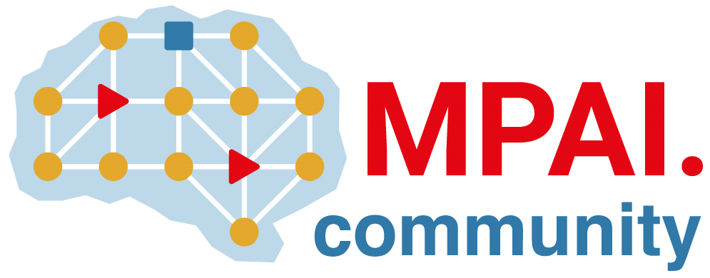 | Moving Picture, Audio and Data Coding by Artificial Intelligence  www.mpai.community

Public document
N3143 | 2026/08/19
Source | Requirements (EEV)
Title | Requirements (EEV) progress report and plans
Target | MPAI Community

Requirements (EEV) is adding new elements toward the implementation of EEV-0.7

