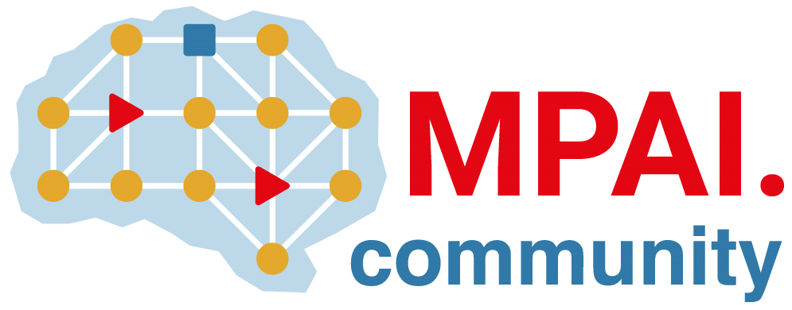 | Moving Picture, Audio and Data Coding  by Artificial Intelligence  www.mpai.community

Public document
N3144 | 2026/08/19
Source | Requirements (EVC)
Title | MPAI-EVC progress report and plans
Target | MPAI Community

The exploration on joint down-sampling and up-sampling filter optimisation is moving toward implementation. Currently, the effect of video-compression between the two filters is not considered.
.

