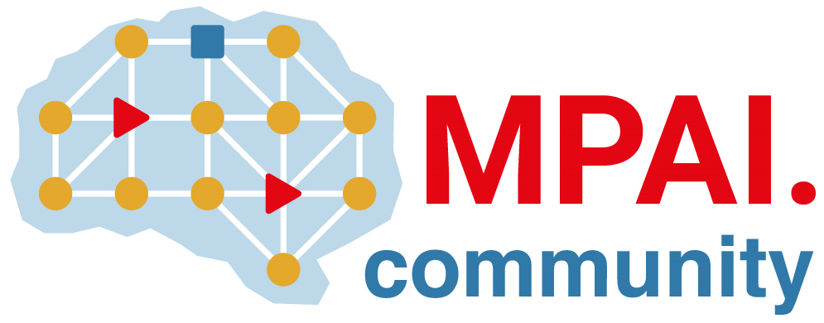 | Moving Picture, Audio and Data Coding by Artificial Intelligence  www.mpai.community

Public document
N3176 | 2026/09/30
Source | 72nd MPAI General Assembly (MPAI-72)
Title | MPAI-72 Press Release
Target | MPAI Community

MPAI marks its sixth anniversary with the publication of Thalia

Geneva, Switzerland – 30 September 2026. MPAI – Moving Picture, Audio and Data Coding by Artificial Intelligence – the international, non-profit, unaffiliated organisation developing AI-based data coding standards – has concluded its 72nd General Assembly (MPAI-72), marking the sixth anniversary of MPAI's founding with the final approval of the MPAI as a Service (MPAI-MAS) standard implemented as a demo service Thalia and with the publication of reference software for the Connected Autonomous Vehicle – Technologies (CAV-TEC) V2.0 standard, published with a request for Community Comments.

MPAI as a Service makes it possible to run MPAI applications remotely. This benefits the chain of service providers who can draw on an open market of AI components, leveraging technologies developed by technology developers, to the advantage of end users.

Thalia, accessible at https://thalia.mpai.community/, demonstrates the potential of the MPAI as a Service standard. Using a browser on a desktop computer or smartphone, a user can interact by speech and text with Thalia, an avatar, across six applications built from the MPAI reference software released today and from openly available AI models.

Thalia plays multiple roles such as using a Large Language Model (LLM) to converse with a user (Multimodal Dialogue), responding to questions about pictures (Answer to Multimodal Questions), acting as a personal interpreter across a variety of languages (Multimodal Translation), holding affective conversations with a user, and modulating the features of her speech and face in response to those of the user (Multimodal Affective Dialogue).

Thalia’s operation draws on a range of MPAI standards. The AI Framework specifies an environment enabling the initialisation, dynamic configuration, and control of AI applications implemented as a collection of AI Modules interconnected according to a standard topology. The Process Instance Trust Framework enables a Zero-Trust implementation of the AIF environment. Other standards used include Multimodal Conversation, Object and Scene Description, Portable Avatar Format, and Data Types, Formats and Attributes. These standards are currently published with requests for Community Comments. The Thalia software is also published to facilitate the formulation of comments to the MPAI Secretariat.

MPAI as a Service will be presented online on 2026/10/26 at 16 UTC. Register to attend.

The General Assembly has also published the Connected Autonomous Vehicle – Technologies (CAV-TEC) standard with requests for Community Comments. Previously published as Version 1.1, CAV-TEC is being revised with the inclusion of reference software. The software is a comprehensive implementation of the standard including the human-machine interaction, the environment sensing, the vehicle control, and the motion actuation subsystems. The software, available from the MPAI GitHub at https://github.com/mpai-community/mpai-sw can run in real time if executed on a computer with adequate GPUs. MPAI encourages use of the software and welcomes comments and contributions.

About MPAI
Moving Picture, Audio and Data Coding by Artificial Intelligence (MPAI) is an international, non-profit, unaffiliated organisation developing standards for AI-based data coding. Its standards specify AI Modules (AIMs) – their function and interfaces – rather than AI models, so implementations conforming to the same standard can be freely combined and replaced. More information is available at mpai.community.

MPAI members are legal entities and representatives of academic departments supporting the MPAI mission and able to contribute to the development of standards for the efficient use of data.
Please visit the MPAI website, subscribe to the MPAI Newsletter, and follow MPAI on social media: LinkedIn, Twitter, Facebook, Instagram, and YouTube.

Visit the website, subscribe to the Newsletter and follow MPAI on social media: LinkedIn, Twitter, Facebook, Instagram, and YouTube.

Media contact
MPAI Secretariat, secretariat@mpai.community

MPAI projects and standards
Short overview of MPAI projects and standards is given below.
- AI Framework (MPAI-AIF) – standard for an infrastructure enabling the initialisation, configuration, and control of AI applications built from interconnected AI Modules.
- AI for Health (AIH-HSP) – standard for a system enabling secure collection, AI-based processing, and secure access of health data.
- AI Passport (MPAI-AIP) – develops a standard enabling humans and AI systems understand the parameters characterising an AI system.
- AI Tools – develops open-source implementations of AI standard components (AI Modules), distributed to the community under a 3-Clause BSD licence.
- Context-based Audio Enhancement (CAE-USC) – standards to improves audio quality across applications from home entertainment to professional studio.
- Connected Autonomous Vehicle (CAV-TEC) – standards for the subsystems and AI components of a connected autonomous vehicle.
- Compression and Understanding of Industrial Data (CUI-CPP) – standards for predicting company performance from governance, financial, and risk data.
- End-to-End Video Coding (MPAI-EEV) – develops a standard to reduces the bits needed to represent video using AI-based end-to-end coding technologies.
- AI-Enhanced Video Coding (MPAI-EVC) – develops specifications for joint AI-based down- and up-sampling filters.
- Governance of the MPAI Ecosystem (MPAI-GME) – standard specifying the operation of the MPAI ecosystem: implementers, performance assessors, the MPAI Store, and end users.
- Human and Machine Communication (MPAI-HMC) – standard enabling multimodal communication between entities (either humans and machines).
- Multimodal Conversation (MPAI-MMC) – standards technologies for richer, more human-like conversation between human and machine.
- MPAI Metaverse Model (MMM-TEC) – standards enabling interoperability between metaverse clients and instances, covering architecture, technologies, and functional profiles.
- Neural Network Watermarking (NNW-TEC) – standards to evaluate parameters and performance of neural networks made traceable thanks to watermarking and fingerprinting.
- Object and Scene Description (MPAI-OSD) – standard for the digital representation of spatial information for audio and visual objects and scenes, used across multiple MPAI standards.
- Portable Avatar Format (MPAI-PAF) – standard for avatars, including speech, synchronised lip movement, and body gestures, for a variety of applications.
- Process Instance Trust Framework (MPAI-PTF) – develops standard to establish and assess trust in an AI-based process instance whose AI Modules may have unknown reliability.
- AI Module Profiles (MPAI-PRF) – enables an AI Module to signal its input data, output data, and functionality.
- Server-based Predictive Multiplayer Gaming (MPAI-SPG) – standard addressing data loss and cheating in server-based predictive multiplayer gaming.
- Data Types, Formats, and Attributes (MPAI-TFA) – specifies Data Type Qualifiers – the Sub-Types, Formats, and Attributes of a Data Type – for enhanced interoperability.
- XR Venues (XRV-LTP) – develops standards for applications combining Extended Reality with AI across physical and digital environments; currently live theatrical performance.

