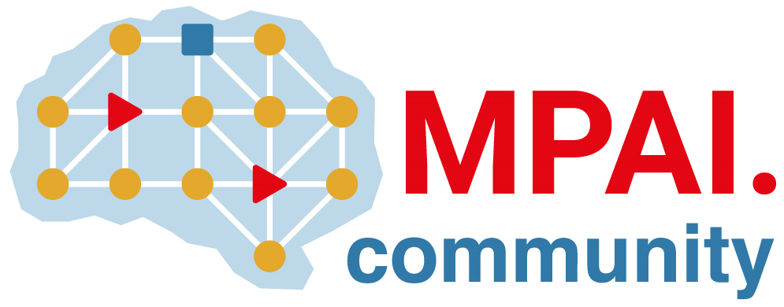 | Moving Picture, Audio and Data Coding by Artificial Intelligence  www.mpai.community

Public document
N3200 | 2026/09/30
Source | Requirements (EEV)
Title | MPAI-EEV progress report and plans
Target | MPAI Community

EEV-0.7 is progressing. Interim results give approximately 12% improvement over VVC.

