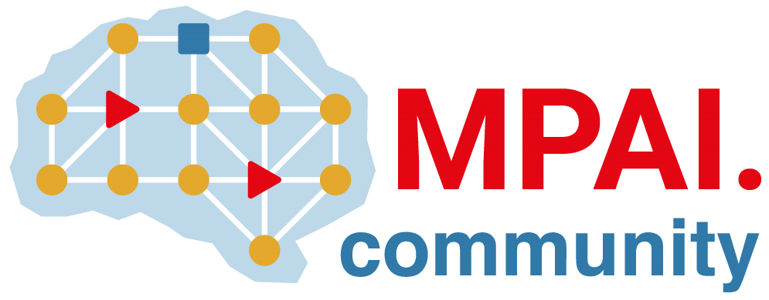 | Moving Picture, Audio and Data Coding by Artificial Intelligence  www.mpai.community

Public document
N3234 | 2026/10/28
Source | 73rd MPAI General Assembly (MPAI-73)
Title | MPAI-73 Press Release
Target | MPAI Community

MPAI publishes Live Theatrical Performance standard for Community Comments

Geneva, Switzerland – 28 October 2026. MPAI – Moving Picture, Audio and Data Coding by Artificial Intelligence – the international, non-profit, unaffiliated organisation developing AI-based data coding standards – has concluded its 73rd General Assembly (MPAI-73), with the publication of the Live Theatrical Performance V1.0 standard with a request for Community Comments.

The Live Theatrical Performance (XRV-LTP) V1.0 brings two mainstream technologies to the theatre and performing arts industry: Artificial Intelligence (AI) technologies simplify show operation allowing complex shows to run in smaller venues while streamlining the mounting of performances across diverse venues, and Extended Reality (XR) technologies support the extension of the physical performance into the metaverse as a digital twin. Register to attend the public presentation of the Live Theatrical Performance to be held on 17 November, 18:00 UTC.
About MPAI
Moving Picture, Audio and Data Coding by Artificial Intelligence (MPAI) is an international, non-profit, unaffiliated organisation developing standards for AI-based data coding. Its standards specify AI Modules (AIMs) – their function and interfaces – rather than AI models, so implementations conforming to the same standard can be freely combined and replaced. More information is available at mpai.community.

MPAI members are legal entities and representatives of academic departments supporting the MPAI mission and able to contribute to the development of standards for the efficient use of data.
Please visit the MPAI website, subscribe to the MPAI Newsletter, and follow MPAI on social media: LinkedIn, Twitter, Facebook, Instagram, and YouTube.

Visit the website, subscribe to the Newsletter and follow MPAI on social media: LinkedIn, Twitter, Facebook, Instagram, and YouTube.

Media contact
MPAI Secretariat, secretariat@mpai.community

MPAI projects and standards
Short overview of MPAI projects and standards is given below.
- AI Framework (MPAI-AIF) – standard for an infrastructure enabling the initialisation, configuration, and control of AI applications built from interconnected AI Modules.
- AI for Health (AIH-HSP) – standard for a system enabling secure collection, AI-based processing, and secure access of health data.
- AI Passport (MPAI-AIP) – develops a standard enabling humans and AI systems understand the parameters characterising an AI system.
- AI Tools – develops open-source implementations of AI standard components (AI Modules), distributed to the community under a 3-Clause BSD licence.
- Context-based Audio Enhancement (CAE-USC) – standards to improves audio quality across applications from home entertainment to professional studio.
- Connected Autonomous Vehicle (CAV-TEC) – standards for the subsystems and AI components of a connected autonomous vehicle.
- Compression and Understanding of Industrial Data (CUI-CPP) – standards for predicting company performance from governance, financial, and risk data.
- End-to-End Video Coding (MPAI-EEV) – develops a standard to reduces the bits needed to represent video using AI-based end-to-end coding technologies.
- AI-Enhanced Video Coding (MPAI-EVC) – develops specifications for joint AI-based down- and up-sampling filters.
- Governance of the MPAI Ecosystem (MPAI-GME) – standard specifying the operation of the MPAI ecosystem: implementers, performance assessors, the MPAI Store, and end users.
- Human and Machine Communication (MPAI-HMC) – standard enabling multimodal communication between entities (either humans and machines).
- Multimodal Conversation (MPAI-MMC) – standards technologies for richer, more human-like conversation between human and machine.
- MPAI Metaverse Model (MMM-TEC) – standards enabling interoperability between metaverse clients and instances, covering architecture, technologies, and functional profiles.
- Neural Network Watermarking (NNW-TEC) – standards to evaluate parameters and performance of neural networks made traceable thanks to watermarking and fingerprinting.
- Object and Scene Description (MPAI-OSD) – standard for the digital representation of spatial information for audio and visual objects and scenes, used across multiple MPAI standards.
- Portable Avatar Format (MPAI-PAF) – standard for avatars, including speech, synchronised lip movement, and body gestures, for a variety of applications.
- Process Instance Trust Framework (MPAI-PTF) – develops standard to establish and assess trust in an AI-based process instance whose AI Modules may have unknown reliability.
- AI Module Profiles (MPAI-PRF) – enables an AI Module to signal its input data, output data, and functionality.
- Server-based Predictive Multiplayer Gaming (MPAI-SPG) – standard addressing data loss and cheating in server-based predictive multiplayer gaming.
- Data Types, Formats, and Attributes (MPAI-TFA) – specifies Data Type Qualifiers – the Sub-Types, Formats, and Attributes of a Data Type – for enhanced interoperability.
- XR Venues (XRV-LTP) – develops standards for applications combining Extended Reality with AI across physical and digital environments; currently live theatrical performance.

